**Phase End Project**

**eCommerce Platform Testing**

**Objective:** To deploy applications using Docker containers and later automate the deployment using Jenkinsfile on EC2 instance

**Tools Required:** Visual Studio Code, Eclipse IDE, MySQL, Angular CLI, Docker, Jenkins, AWS

**Prerequisites:** None

**Steps to be followed:**

1. Downloading and extracting the code files
2. Creating a network and running a MySQL container
3. Creating Dockerfiles and running containers for applications
4. Verifying the applications function
5. Configuring the Git repository for both the applications
6. Setting up the Jenkins
7. Creating a Jenkinsfile and CI/CD pipeline in local machine
8. Setting up the AWS RDS database
9. Setting up the EC2 instance
10. Deploying the applications on EC2

**Step 1: Downloading and extracting the code files**

1. Download the **eStore** code files that encompass the code for both the frontend Angular application and the Java backend application

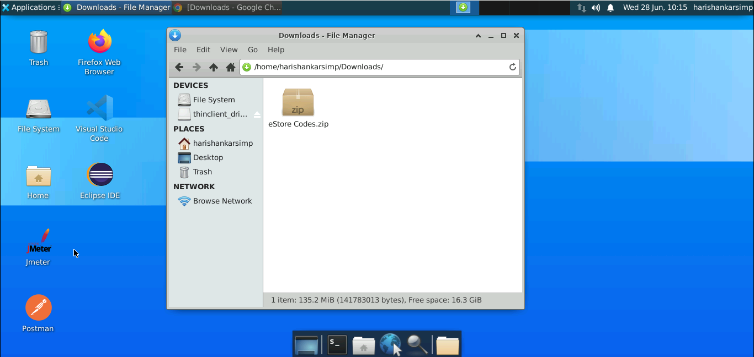

1. Open the terminal inside the **Downloads** directory and unzip the downloaded zip folder

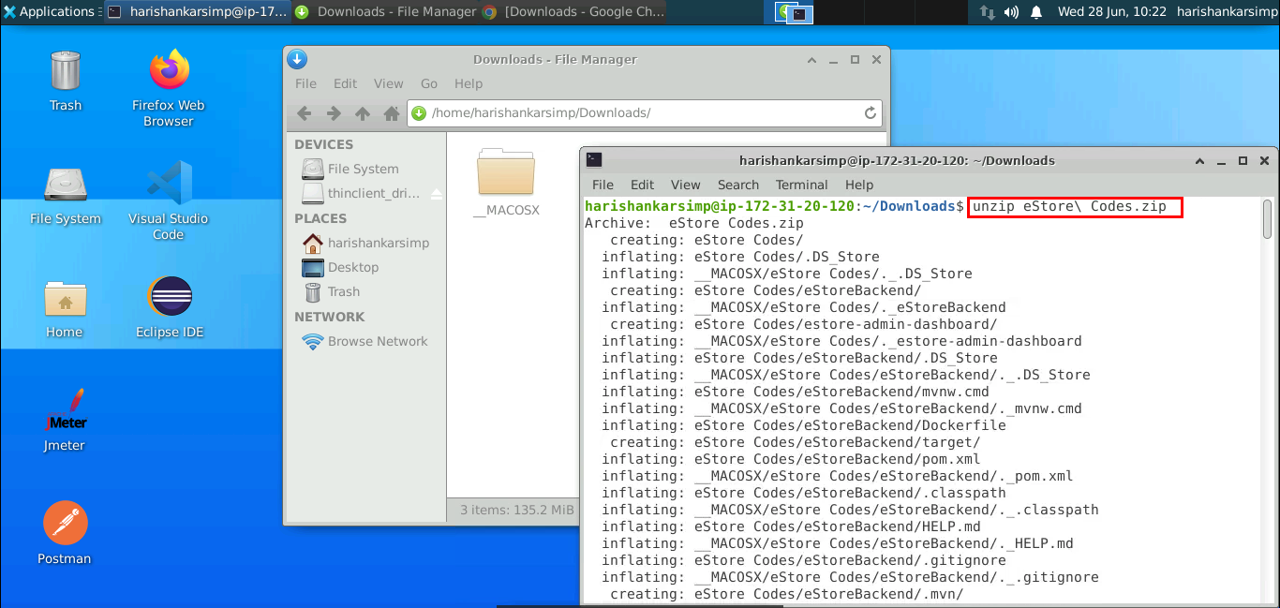

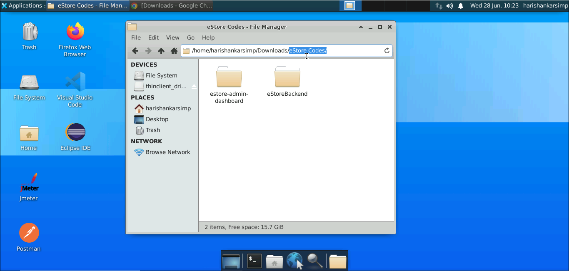

You can see both frontend and backend application folders. To create a Docker container for both application. You need to setup MySQL and Docker initially.

**Step 2: Creating a network and running a MySQL container**

1. Create a new network in Docker so that we can make a connection between MySQL and Java backend and Angular frontend in Docker. Execute the command:

**sudo docker network create estore-mysql**

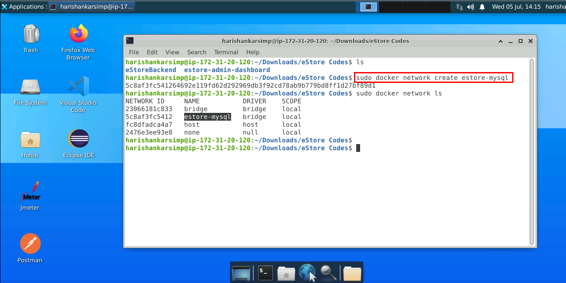

1. Now, pull latest image of MySQL database in Docker:

**sudo docker pull mysql**

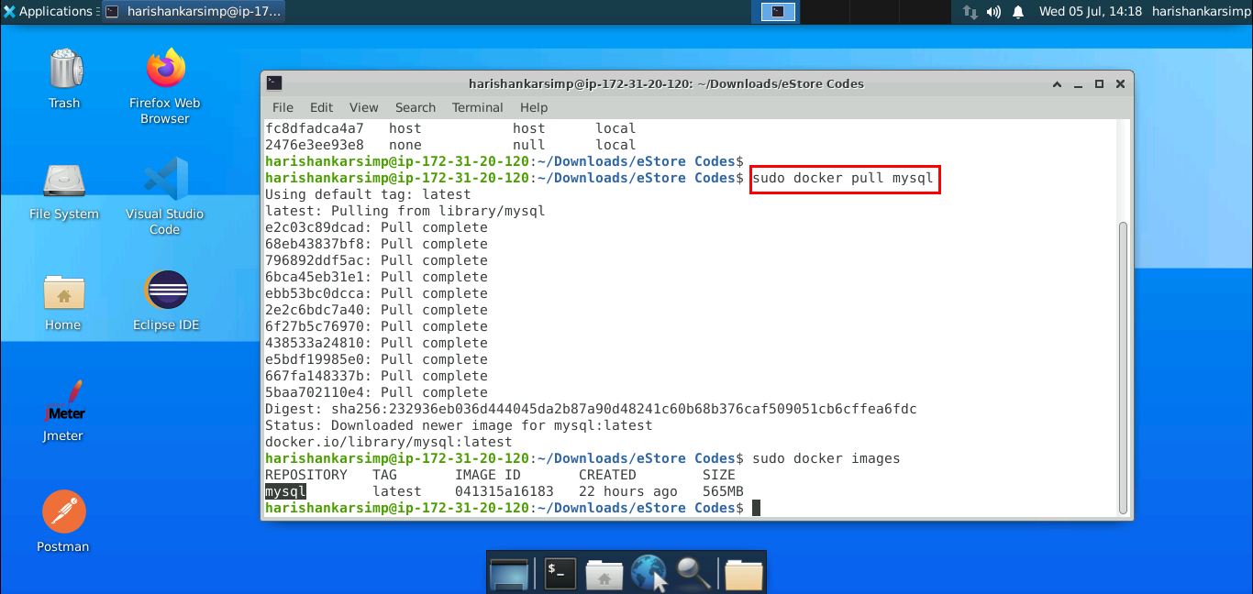

1. Now, run container from MySQL on the created network:

**sudo docker run --name mydb --network estore-mysql -e MYSQL_ROOT_PASSWORD=password -e MYSQL_DATABASE=estoredb -d mysql**

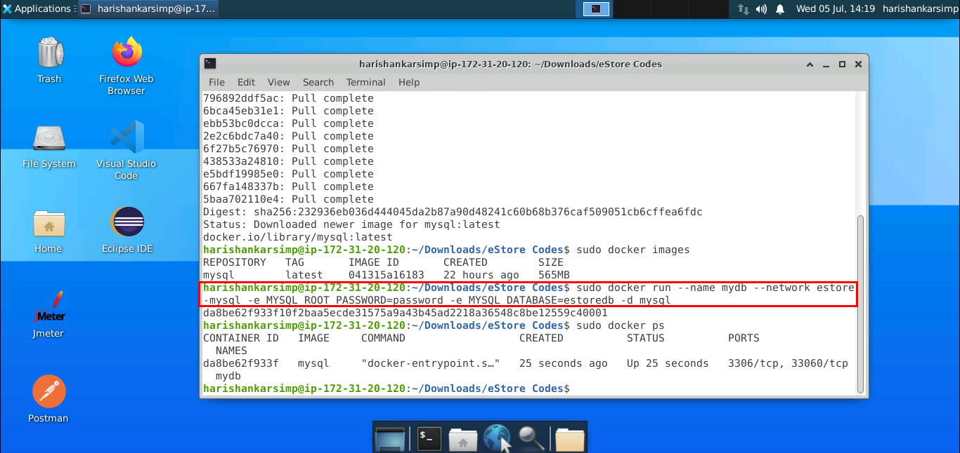

1. Check if the database has been created in MySQL container. Execute the command to access it:

**sudo docker exec -it mydb bash -l**

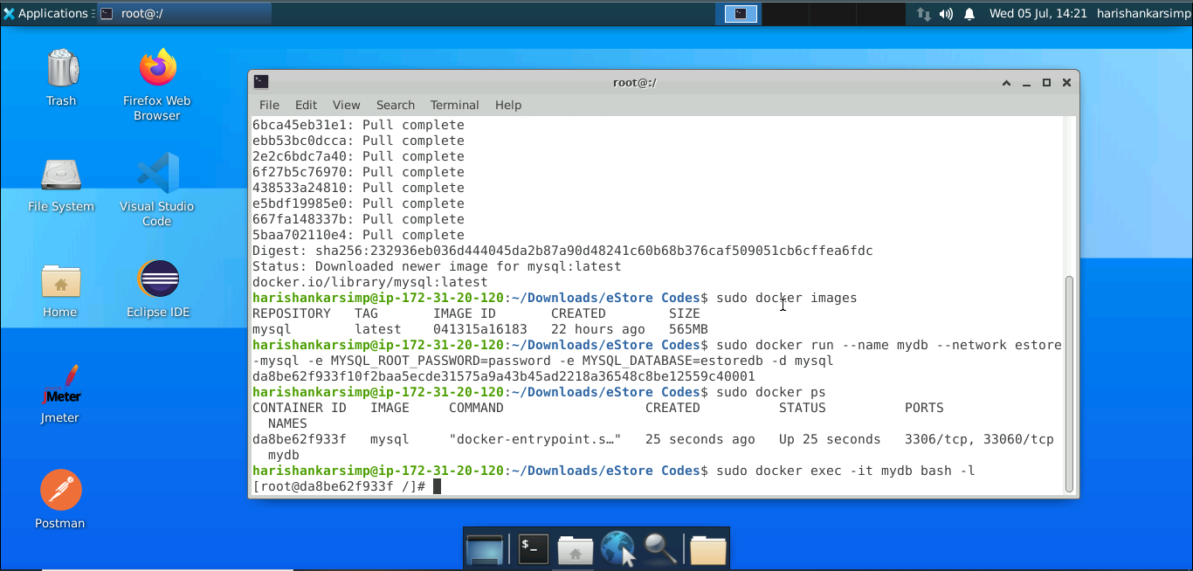

We are inside the MySQL container and able to access the shell of container. Now we can create tables and add admin record which is later required to login for frontend.

1. Run the below command to access the MySQL server:

**mysql -u root -p**

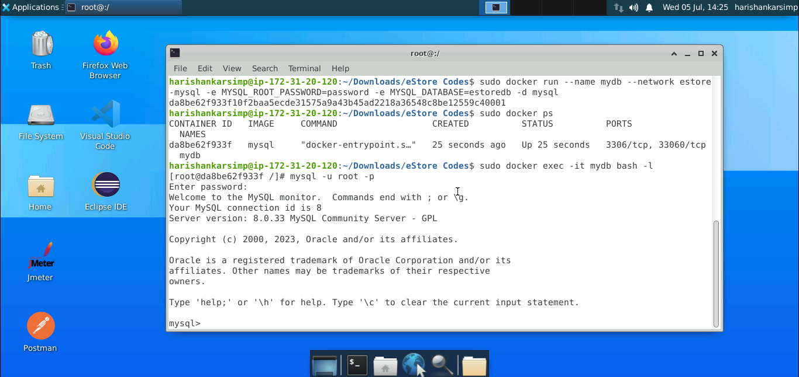

**Note:** Enter **password** if prompt for password.

1. Now you can setup the MySQL database which is required for the application to work. Firstly, create a database in MySQL using the command:

**create database estoredb;**

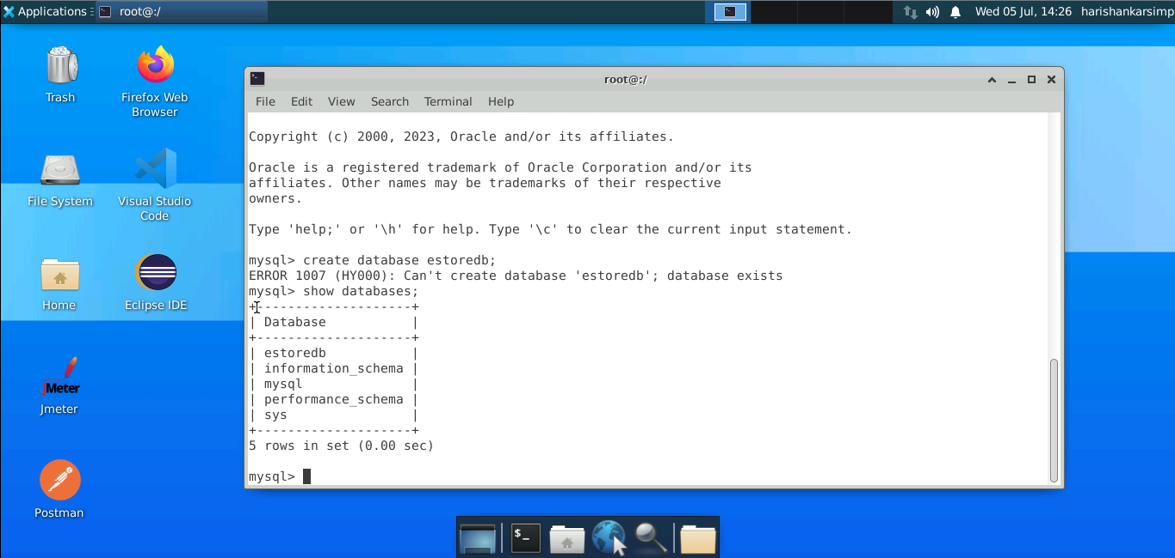

1. Now, run **use estoredb;** command and create admins table:

CREATE TABLE `admins` (

 `admin_id` int NOT NULL,

 `added_on` datetime(6) DEFAULT NULL,

 `email` varchar(255) DEFAULT NULL,

 `full_name` varchar(255) DEFAULT NULL,

 `login_type` int DEFAULT NULL,

 `password` varchar(255) DEFAULT NULL,

 PRIMARY KEY (`admin_id`)

);

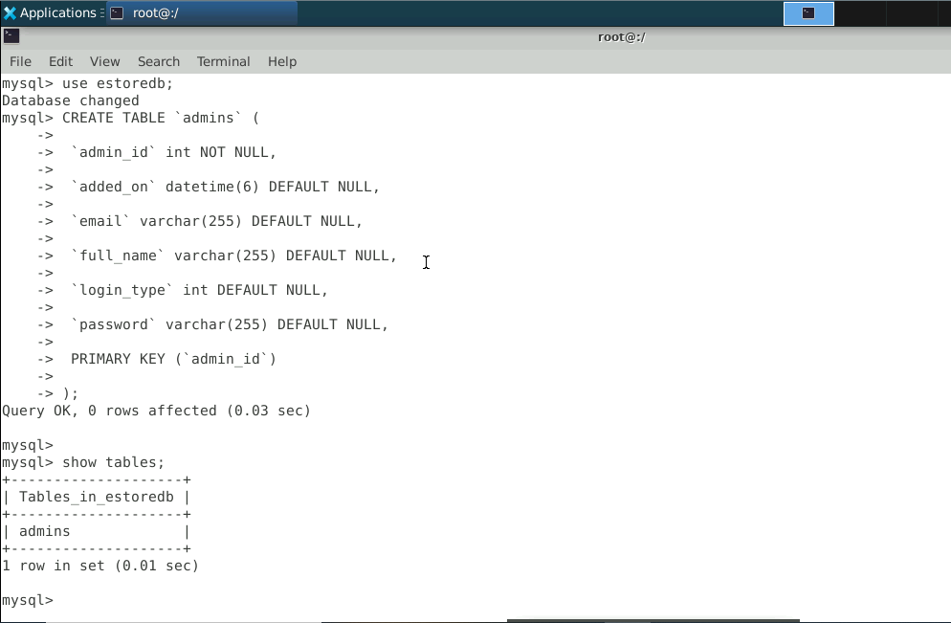

1. Insert a record to the admins table:

**INSERT INTO `admins` VALUES (1,'2023-02-10 00:00:00.000000','admin@example.com','John Watson',1,'admin123');**

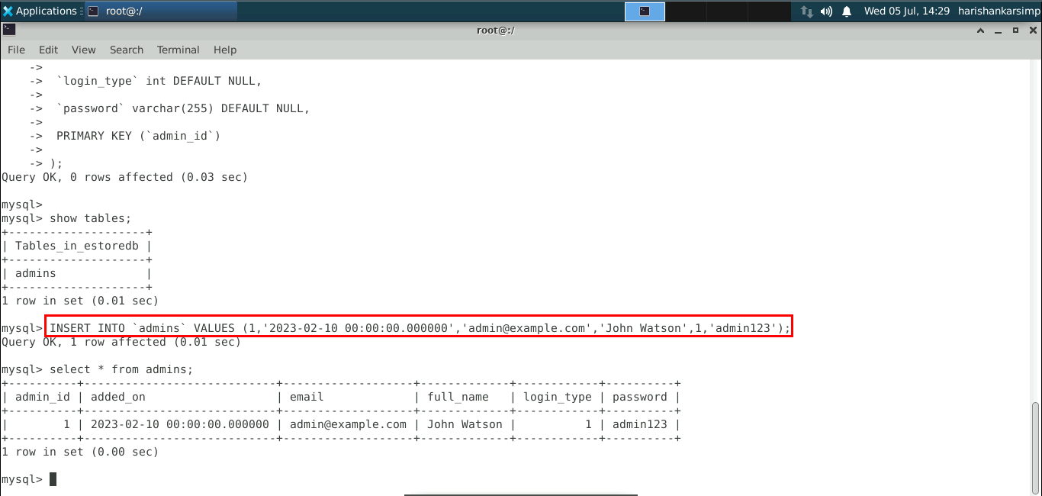

Our Docker network and MySQL container are ready now.

**Step 3: Creating Dockerfiles and running containers for applications**

1. Launch Visual Studio Code and open the **eStore Codes** folder

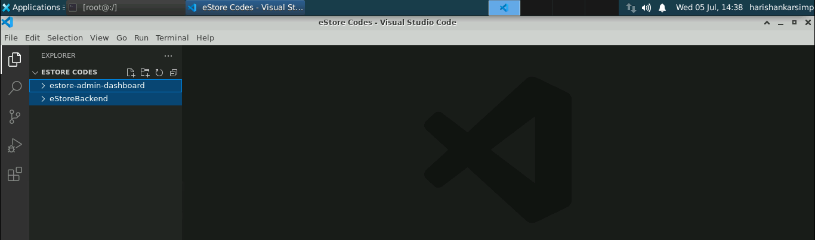

1. Create a **Dockerfile** for the angular frontend application in the root directory

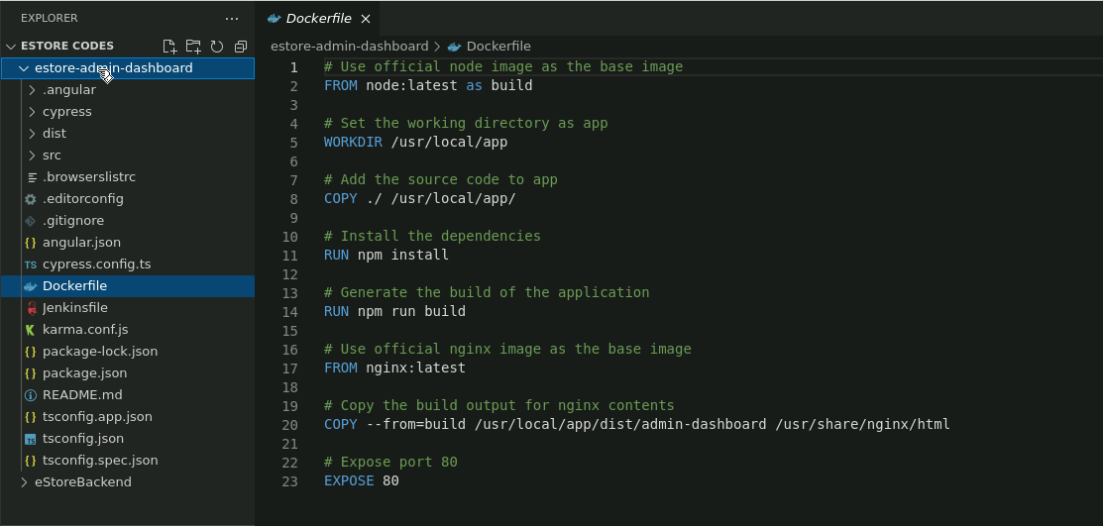

1. Similarly create a **Dockerfile** for Java backend application

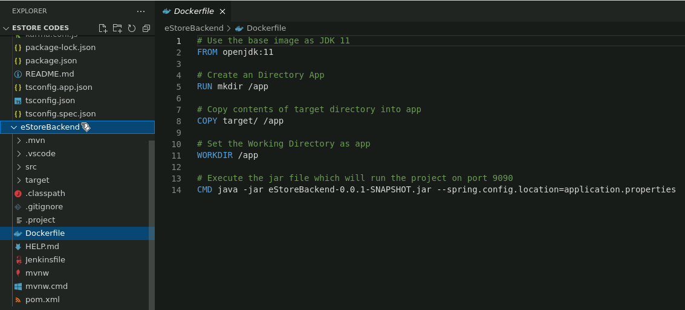

1. Open a terminal, navigate to the frontend application directory, and build the Docker image:

**sudo docker build -t estore-admin .**

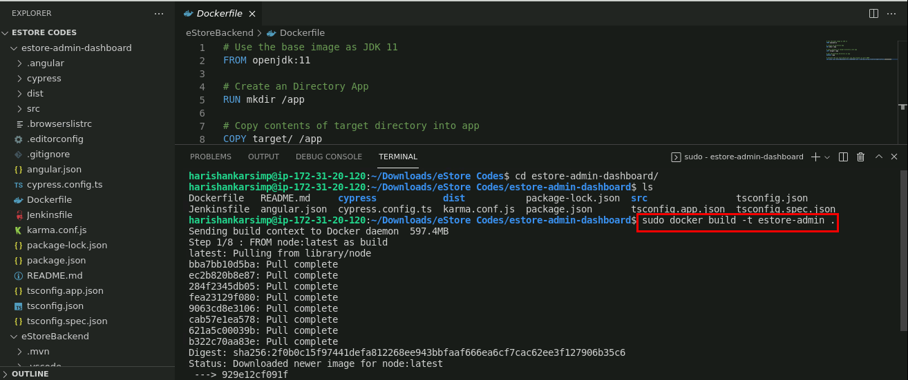

1. Run the below command to check if the image is generated successfully:

**sudo docker images**

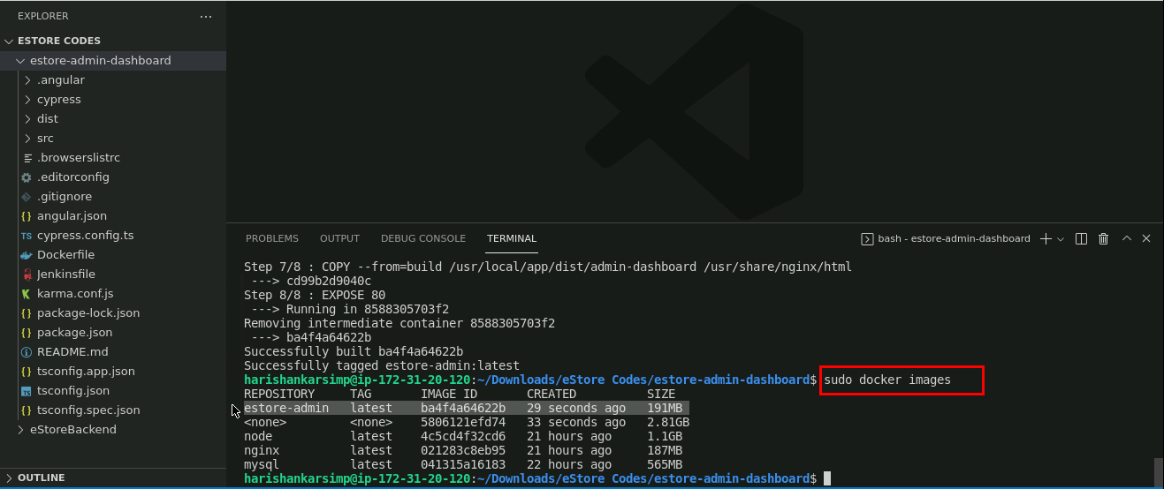

1. Since, the image is generated now we can create container from the image and run it:

**sudo docker run --name=estore-admin-container -d -p 4200:80 --network=estore-mysql estore-admin**

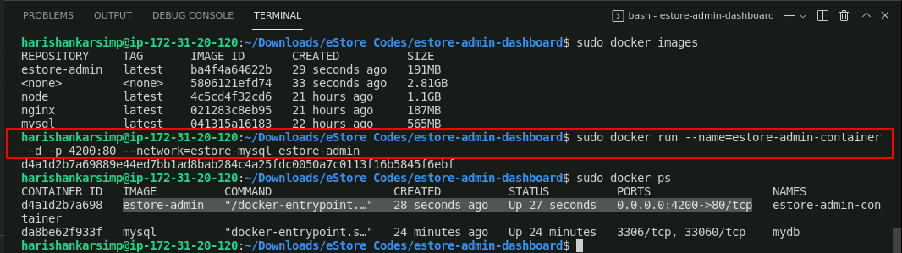

Here we are using port **4200** to run the admin application.

1. Open the browser window and type **localhost:4200** to validate if Angular web admin project is running inside the docker container

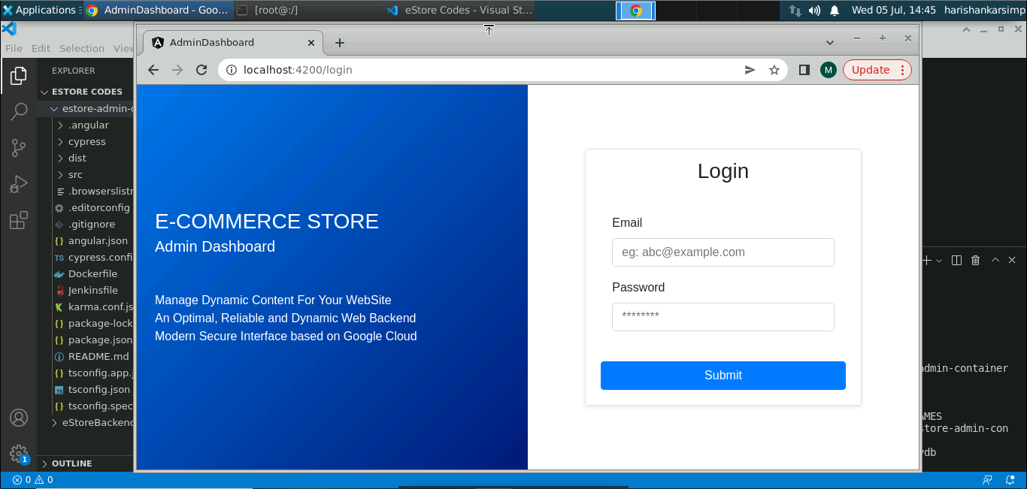

1. Moving ahead for Java backend, we need to externalize **application.properties** file in the main function so that we can give the configuration for MySQL database in Docker Container

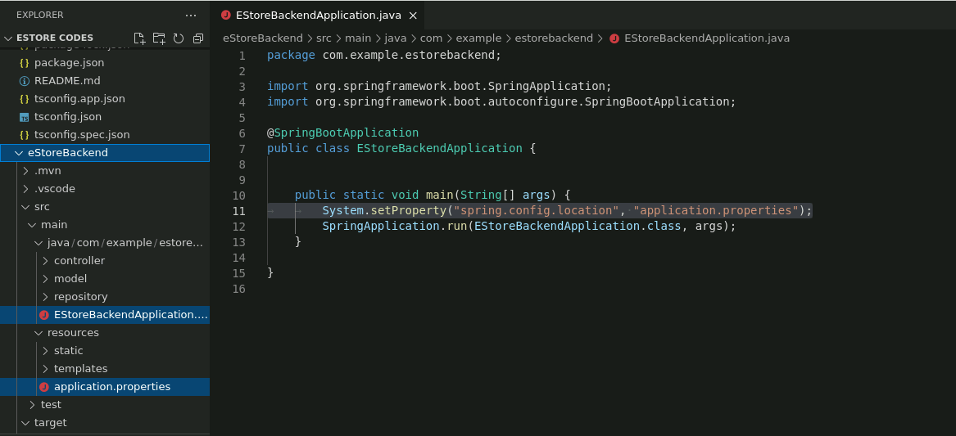

1. Open the terminal, navigate to the Java backend root directory, and run the command:

**mvn clean package**

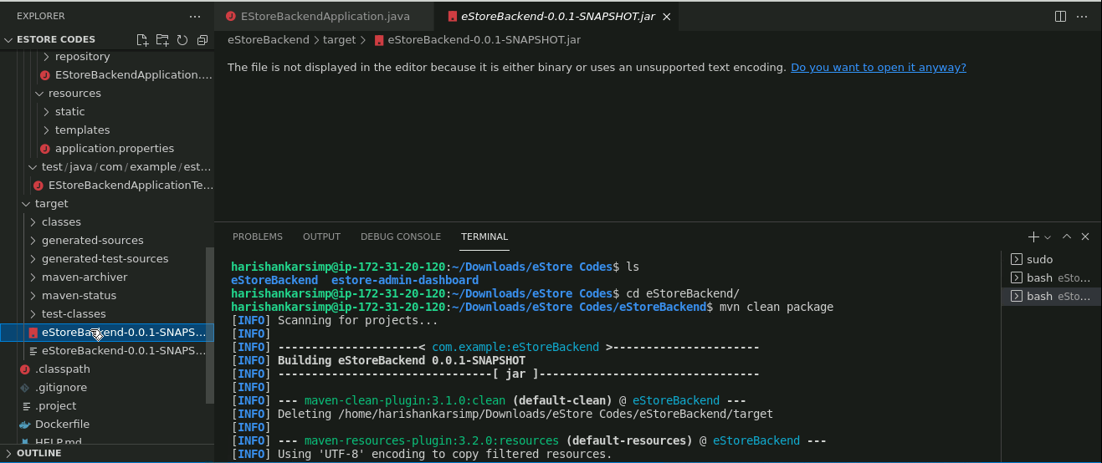

This command will generate a JAR compressed file inside the target directory.

1. Now, copy the **application.properties** file in the **target** directory

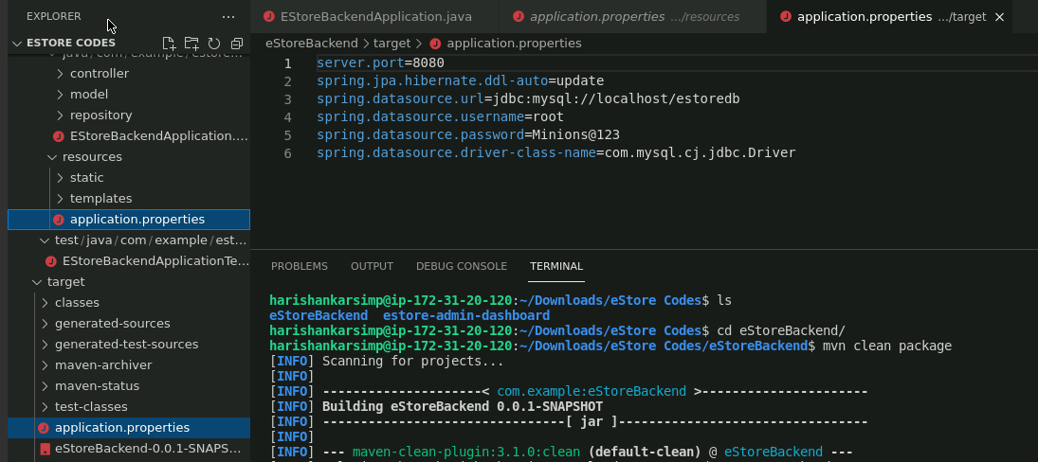

1. Update the **application.properties** file with updated details

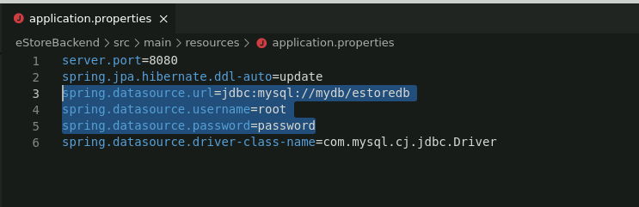

1. Now, create an image for the project. Open the terminal window and execute the command:

**sudo docker build -t estore-backend .**

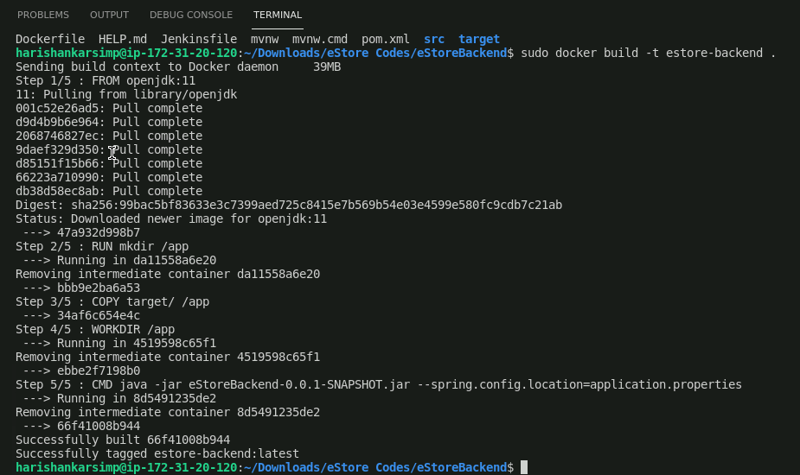

1. Run the command to check if the image is generated successfully:

**sudo docker image ls**

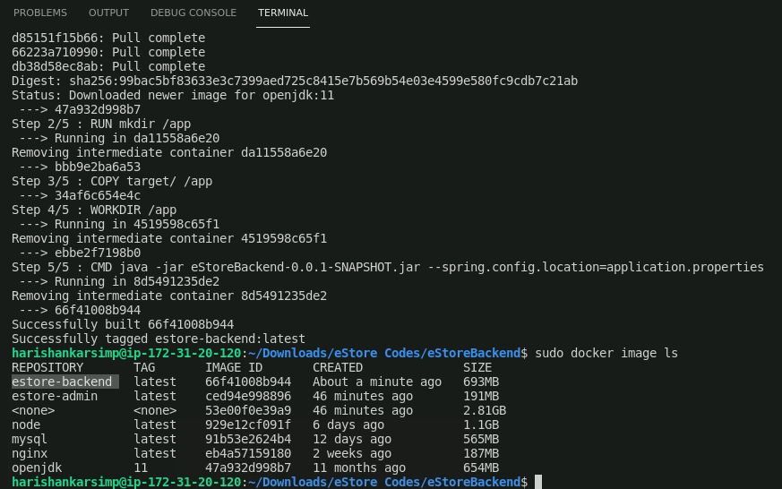

1. Image is generated now we can create container from the image and run it. Use the command:

**sudo docker run --name estore-backend-container -d -p 8080:8080 --network=estore-mysql estore-backend**

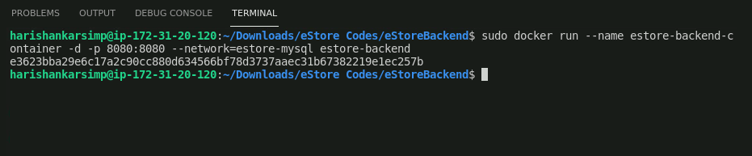

Here we are using port **8080** to run the java backend application, which can be modified in **application.properties** file.

1. Check the container is live or not by executing the command:

**sudo docker ps -a**

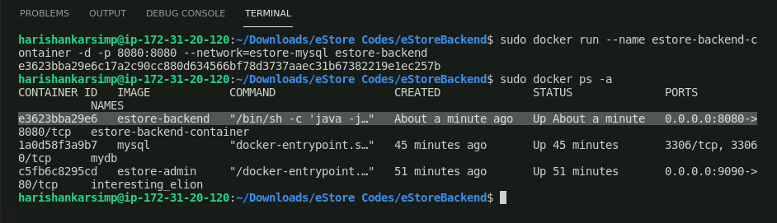

1. Now, open the browser and type **localhost:8080** to check if Java backend is up

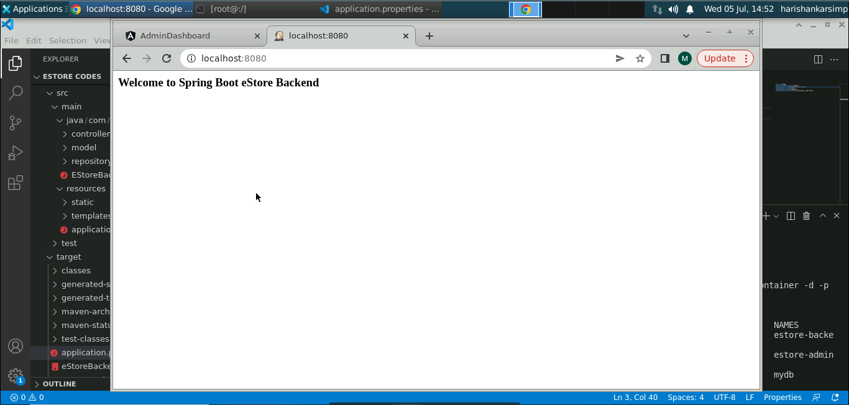

Our frontend and backend applications are up and running using the Docker containers environment and within the same network **(estore-mysql)**.

**Step 4: Verifying the applications function**

1. Navigate to the Angular application and login using the admin credentials we added in the MySQL container:

**Email: admin@example.com**

**Password: admin123**

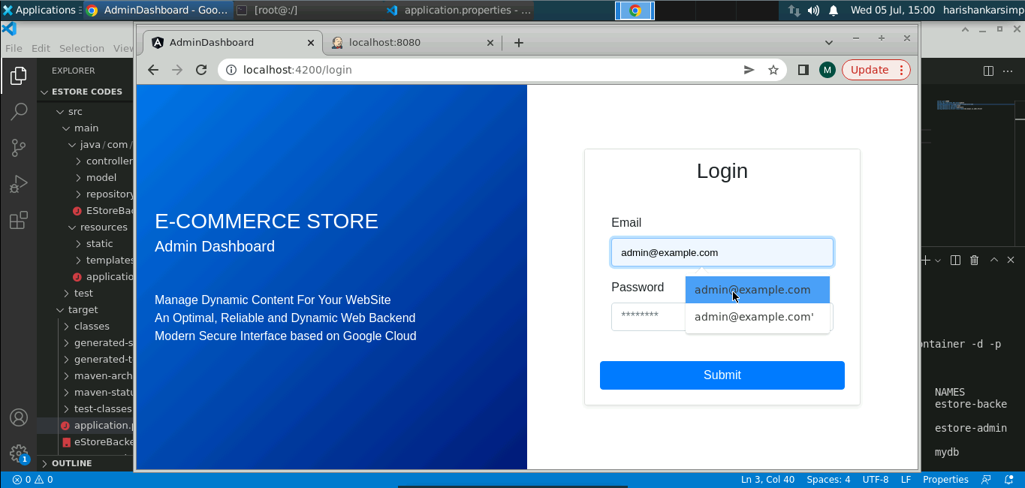

1. Click **Submit**

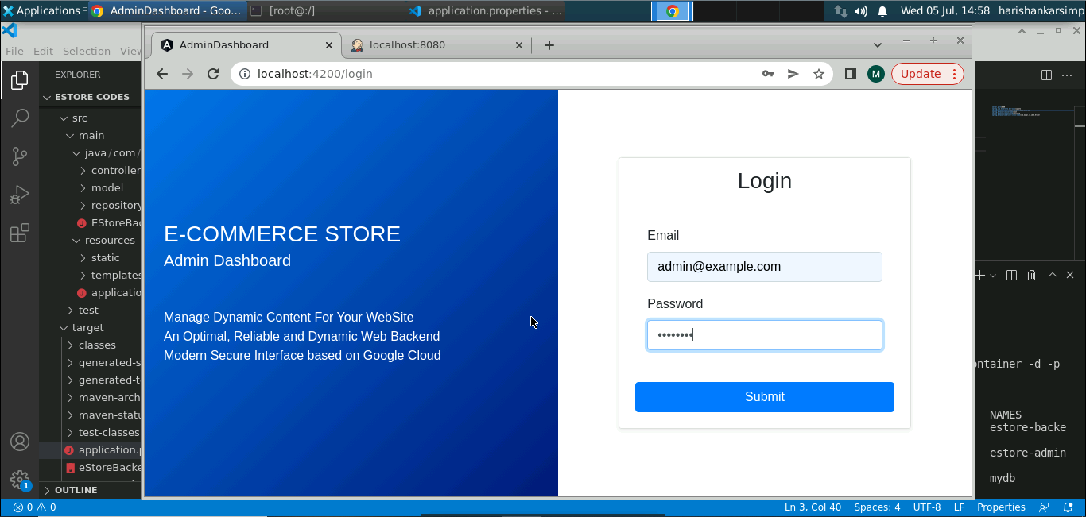

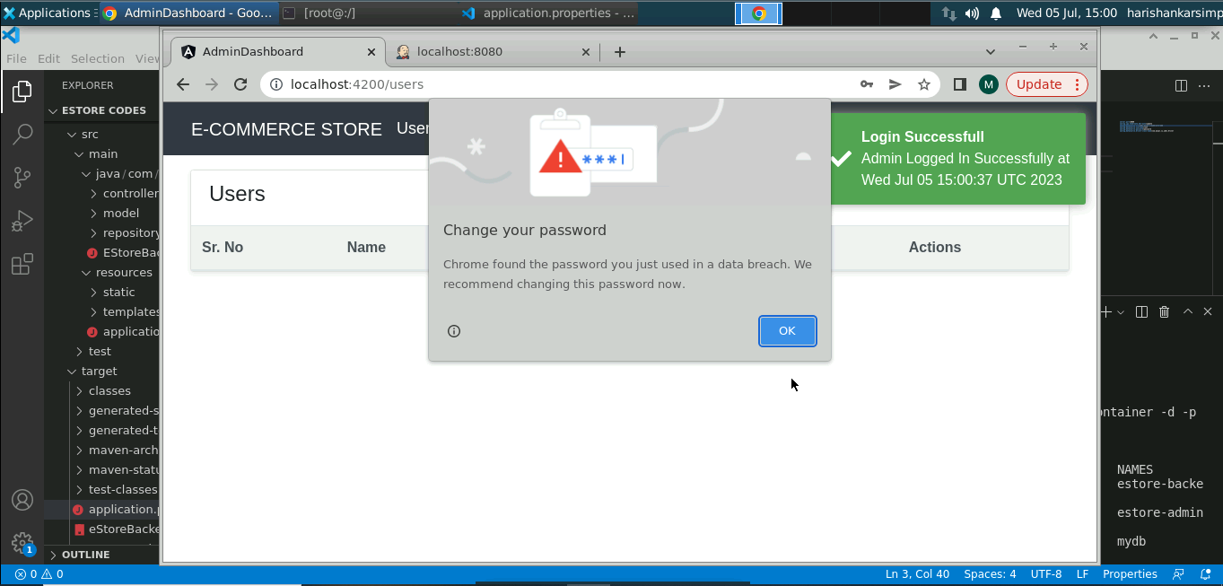

You can see the login is successful. Right now, there are no users available in the database thus the table is empty.

1. You can use postman to add users, products, orders etc

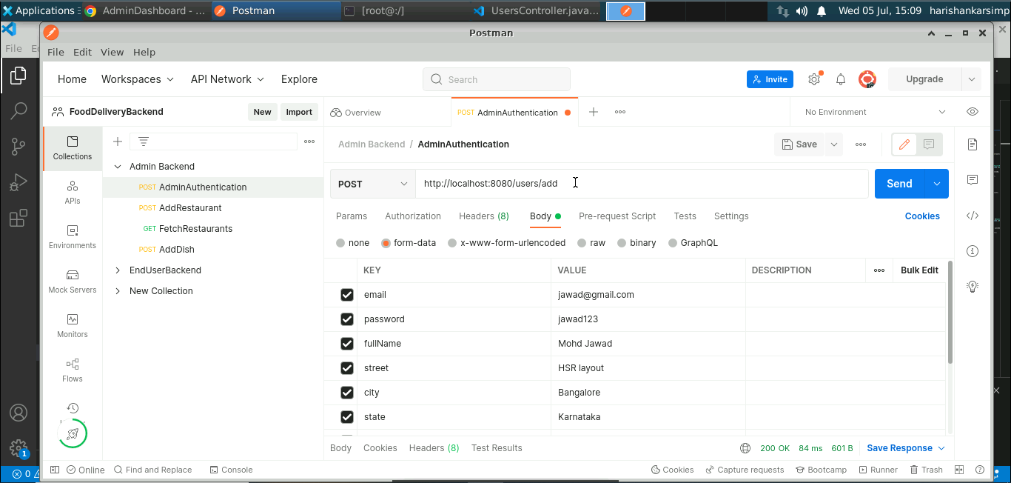

You should receive a **200** status code and successful message on the console for the right insertion.

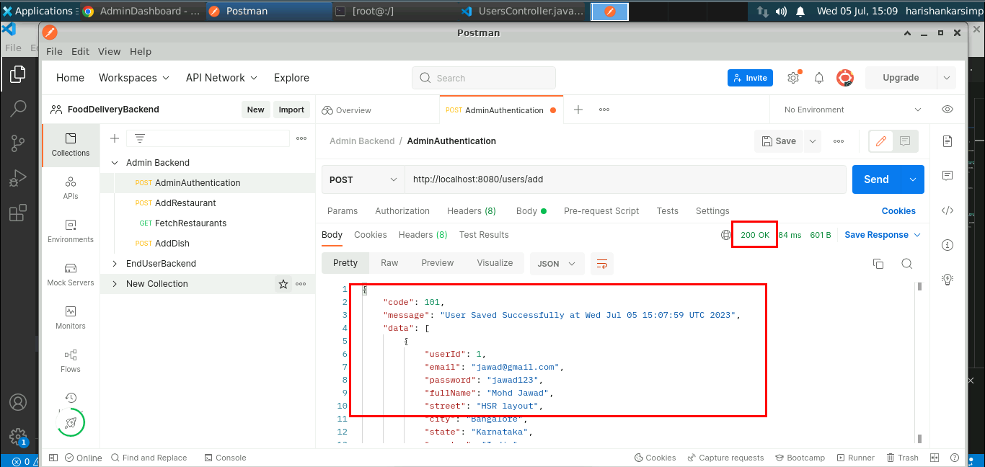

1. Once users are added you can refresh the admin home dashboard page

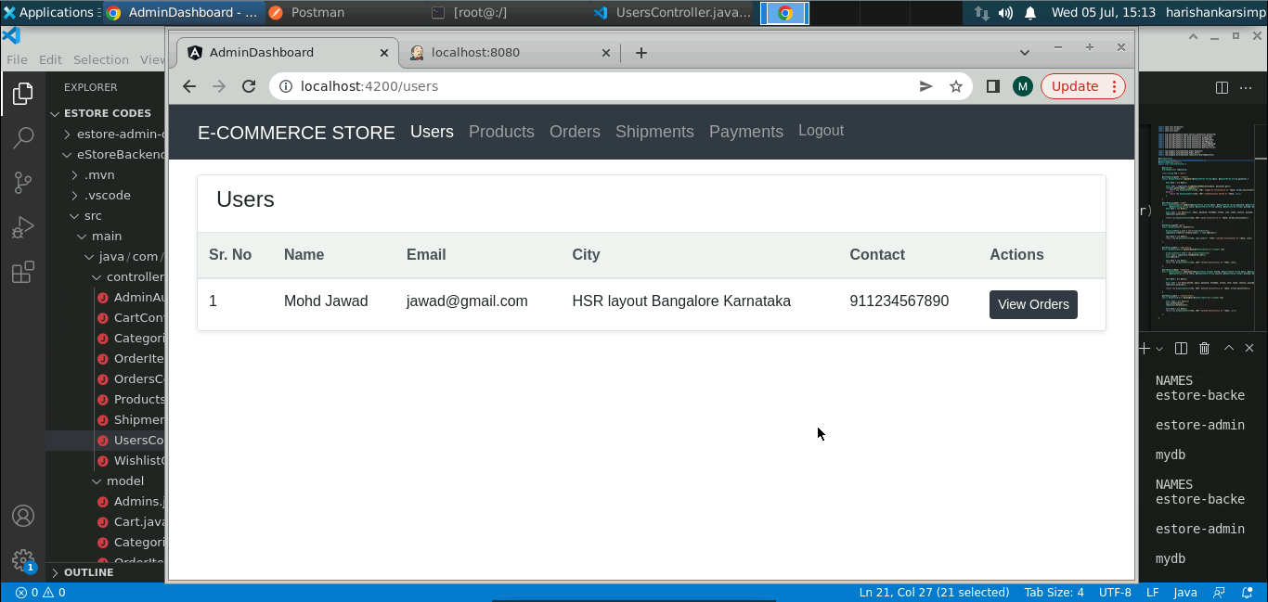

You can see the user details been display that currently added through Postman.

**Step 5: Configuring the Git repository for both the applications**

1. Go to the GitHub and create two repositories for Angular frontend and Java backend applications

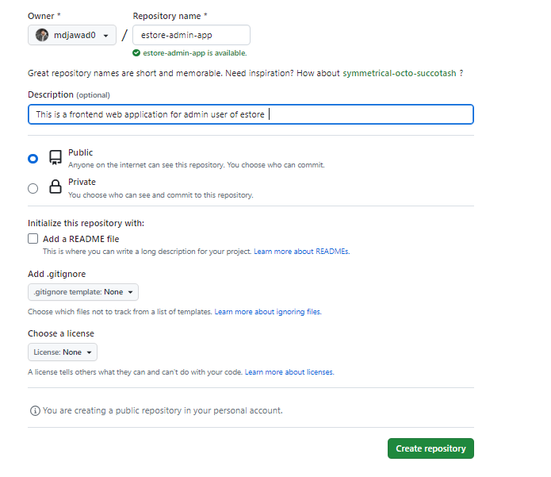

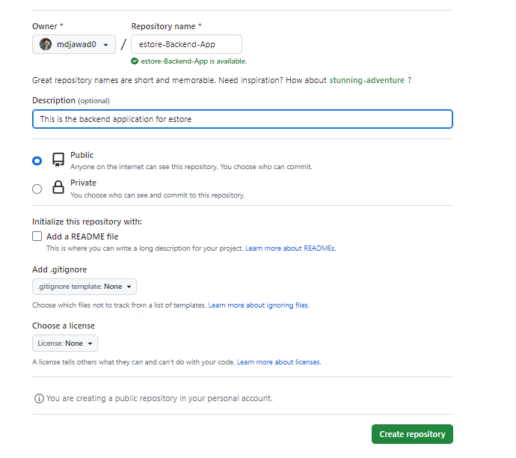

1. Push the files to the created repositories follow git commands

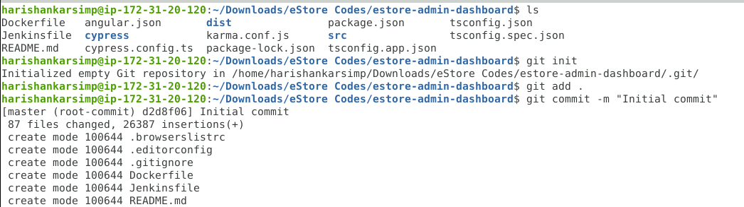

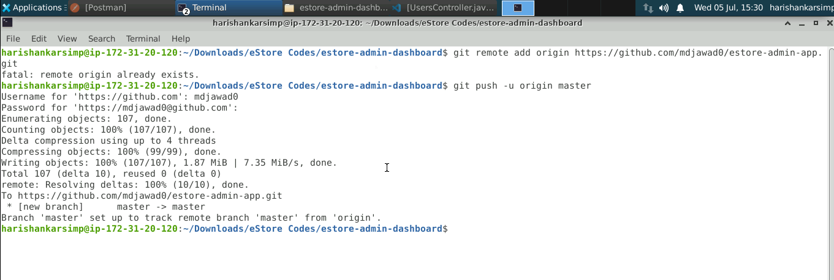

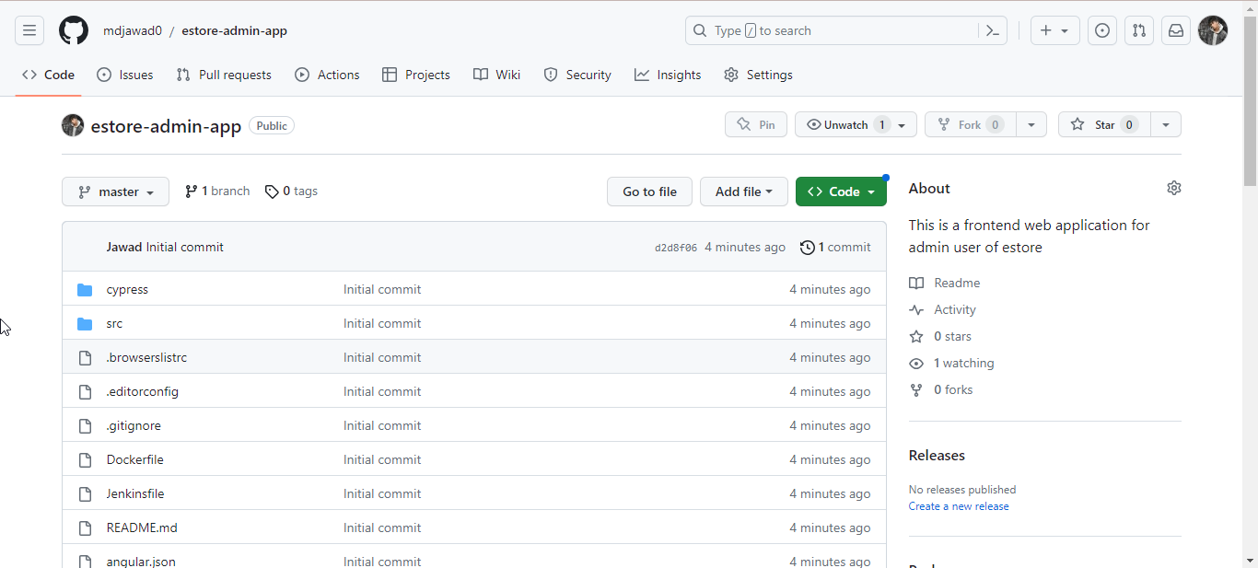

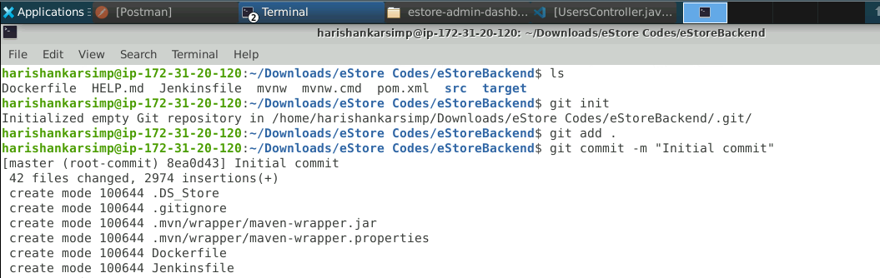

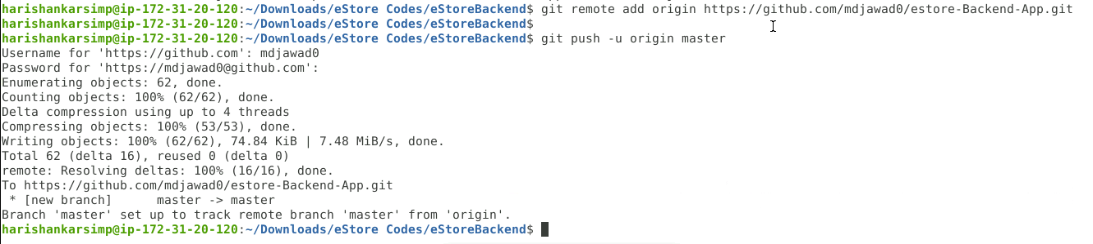

**Step 6: Setting up the Jenkins**

1. Since Jenkins by default uses port **8080** which is already occupied by Java backend, let’s stop it:

**sudo docker stop estore-backend-container**

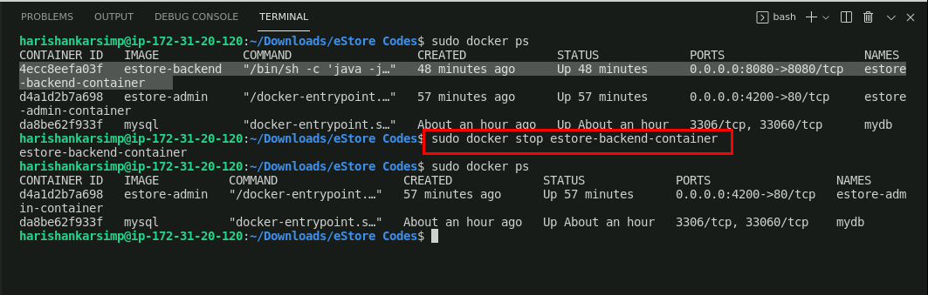

1. Start the Jenkins service using the command:

**sudo service jenkins start**

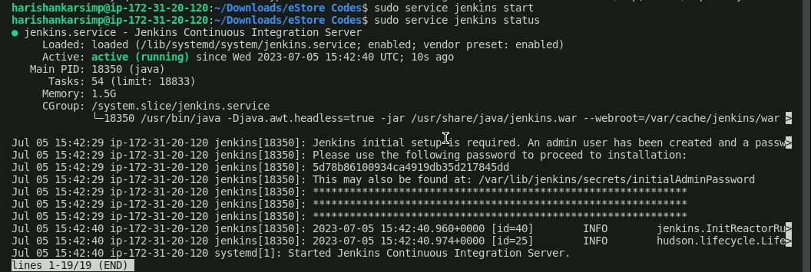

1. Navigate to the **localhost:8080** in the browser

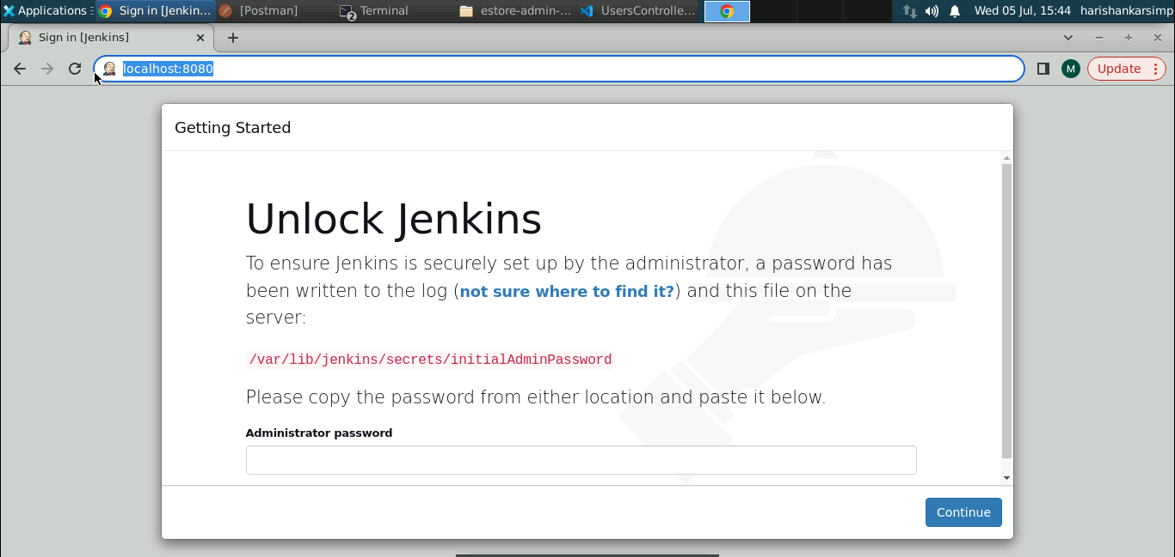

You should see the Jenkins initial page.

1. To unlock the Jenkins, copy the given path and print the hash password using command:

**sudo cat [path]**

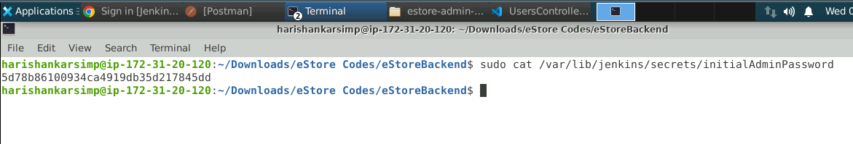

1. Copy paste the hashcode and click **Continue**. Next click on **Install suggested plugins**.

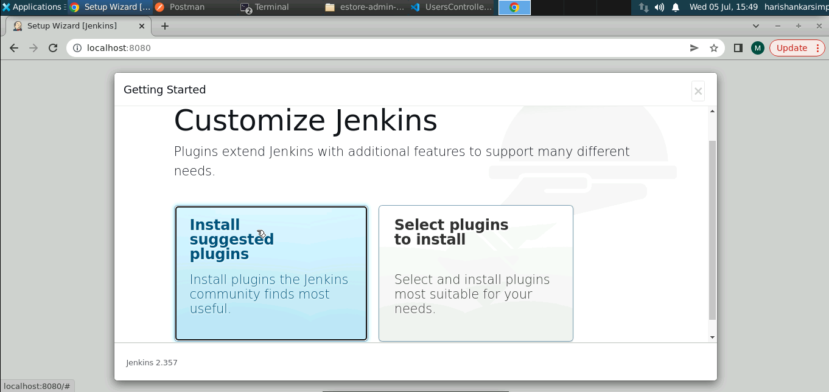

1. Then, provide admin credentials that will be required to login with Jenkins and click on **Save and Continue**

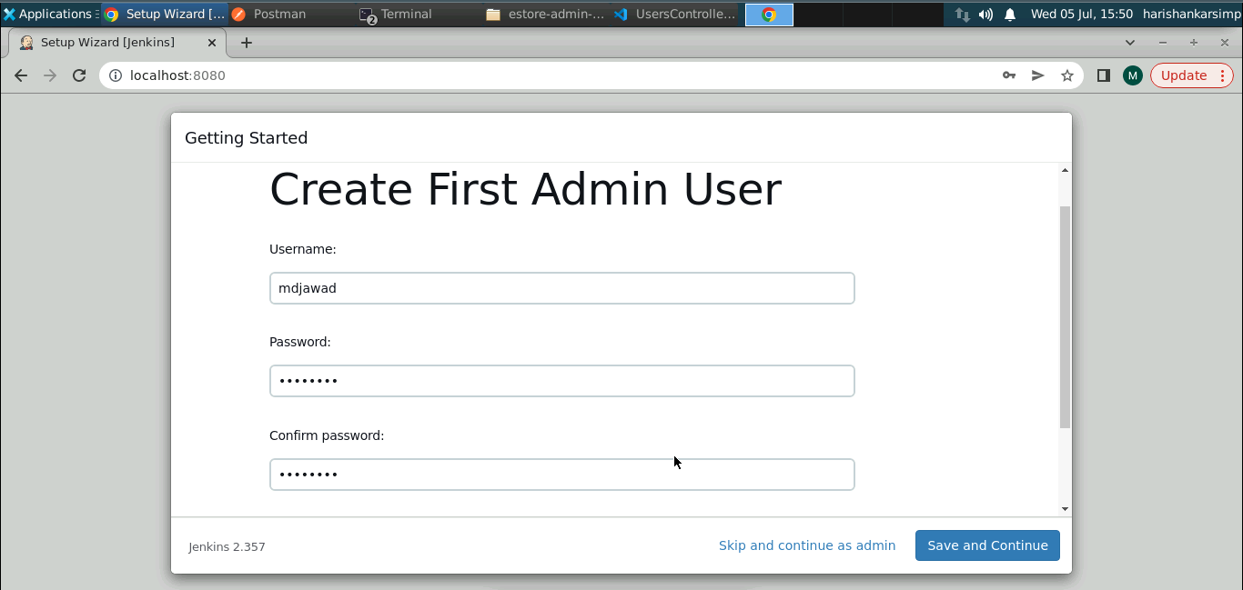

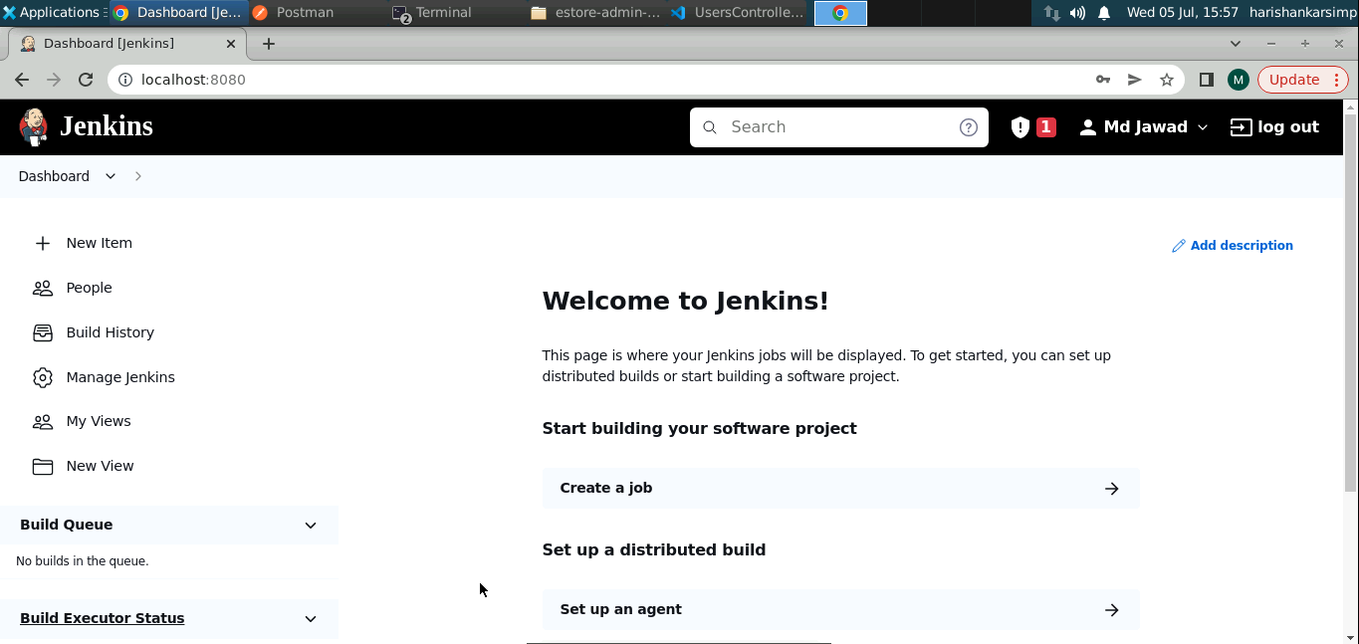

Jenkins is ready to use now.

**Step 7: Creating a Jenkinsfile and CI/CD pipeline in local machine**

1. Create a Jenkinsfile for the Angular project in the root directory

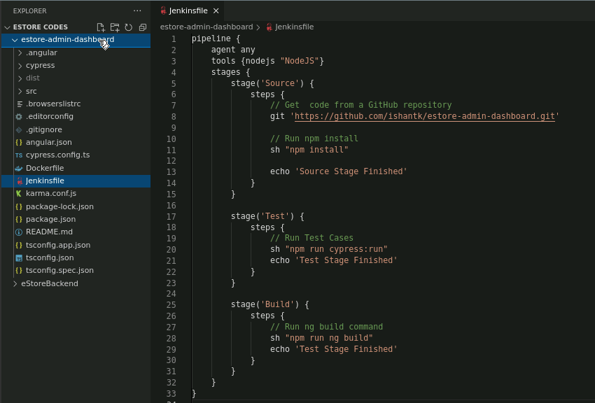

1. Similarly create Jenkinsfile for Java backend project

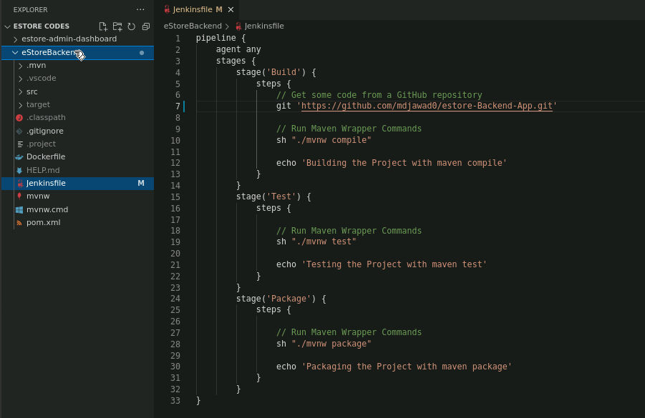

**Note:** Please commit and push the updates in the GitHub repositories.

1. Navigate to the Jenkins dashboard install the NodeJS plugin for the Angular project and then restart Jenkins

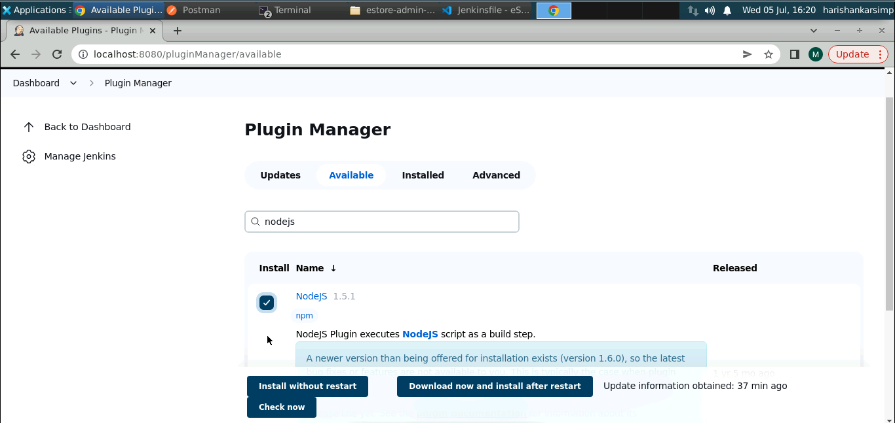

1. You need to make sure that the NodeJS tool is properly configured in your Jenkins environment

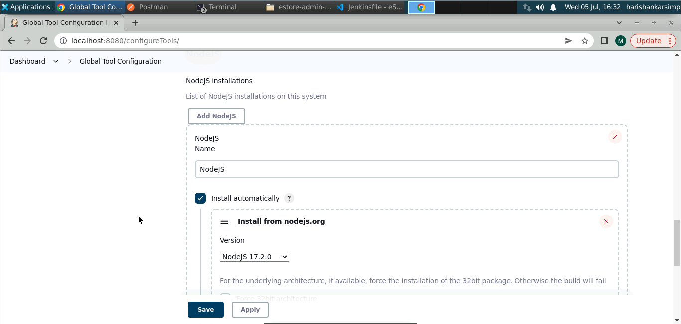

1. Let’s create a new pipeline for Angular project

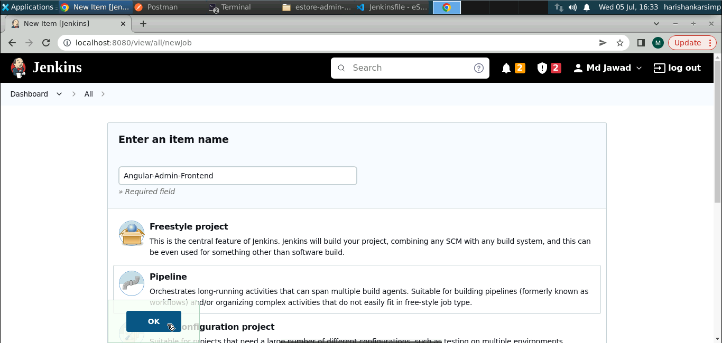

1. Provide the GitHub repository URL under **Advanced Project Options** tab

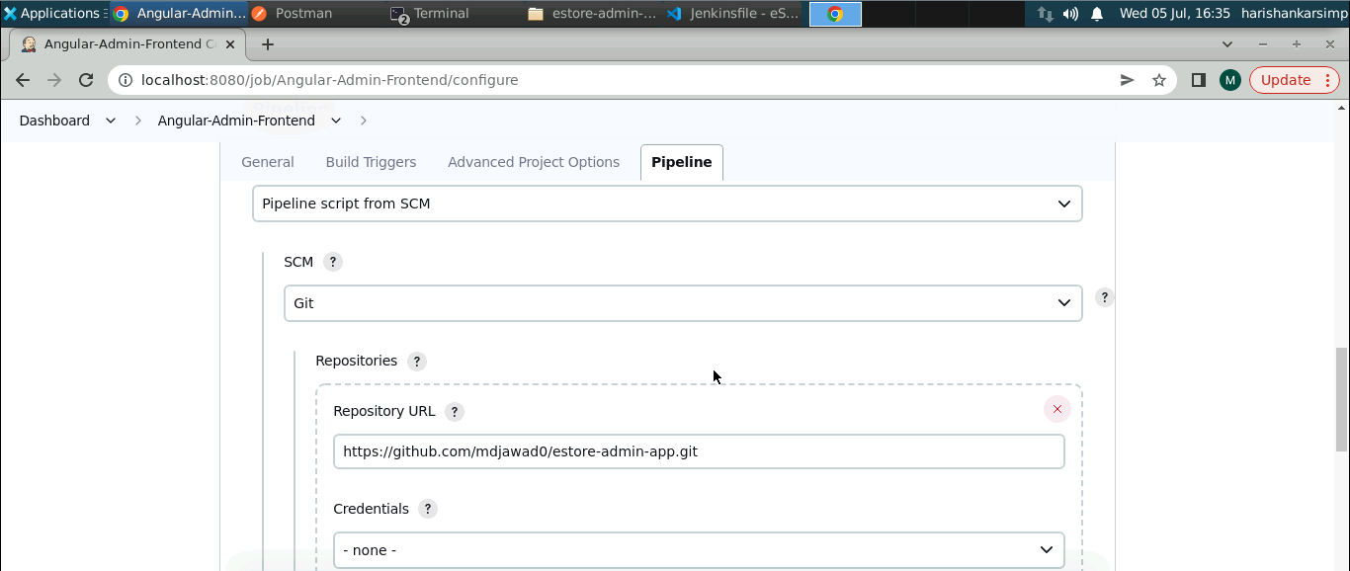

1. Keep the Script Path as **Jenkinsfile** and click on **Save**

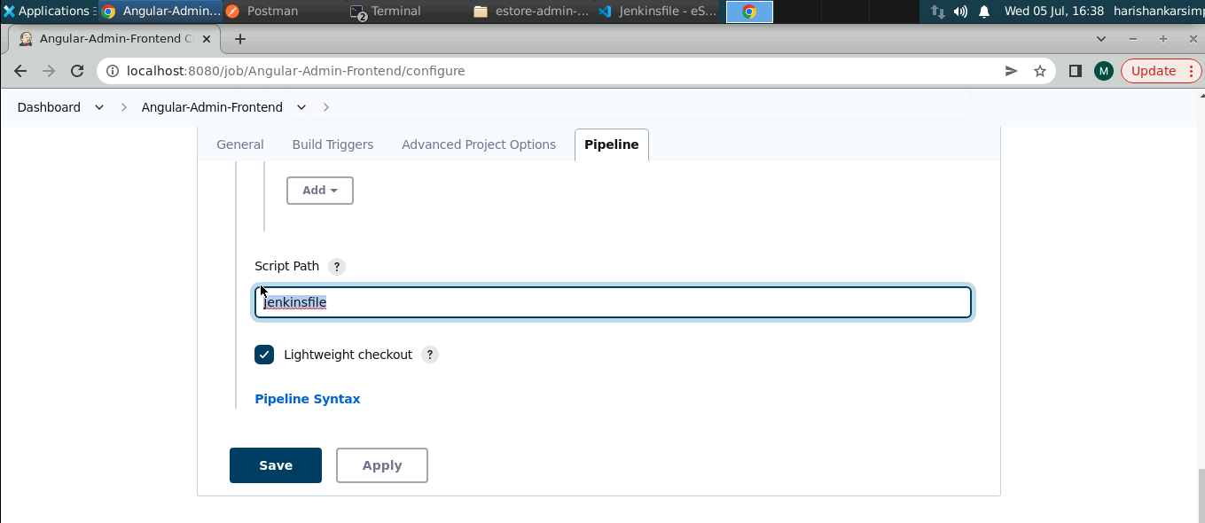

1. Click on **Build Now** to execute the pipeline

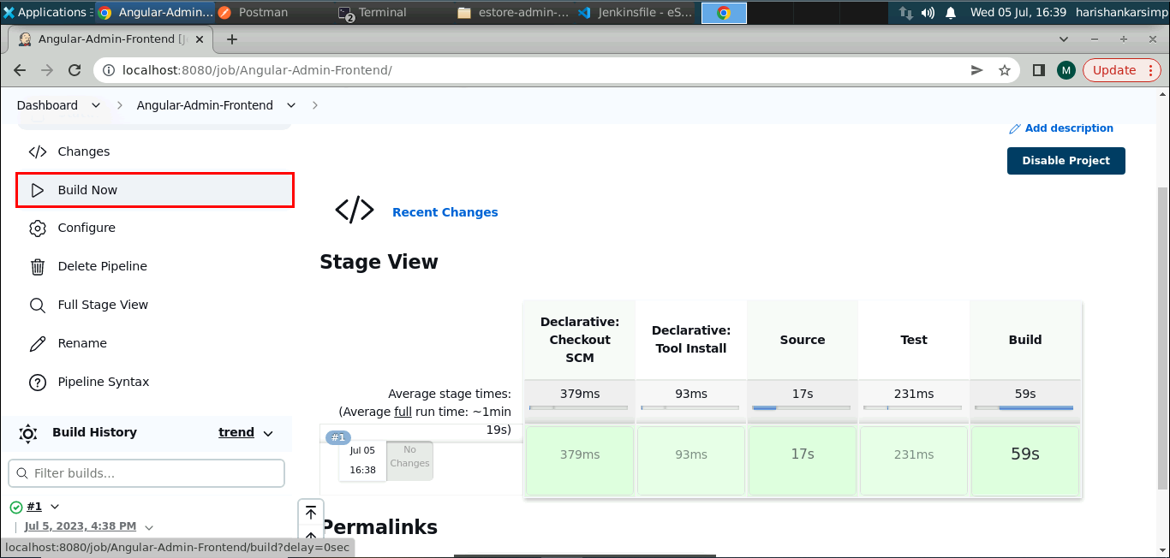

You can see all the defined stages in the Jenkinsfile are passed and successful. Please review your cypress testcases if pipeline fails.

1. Similarly create another pipeline for Java backend project following same steps and click on **Build Now**

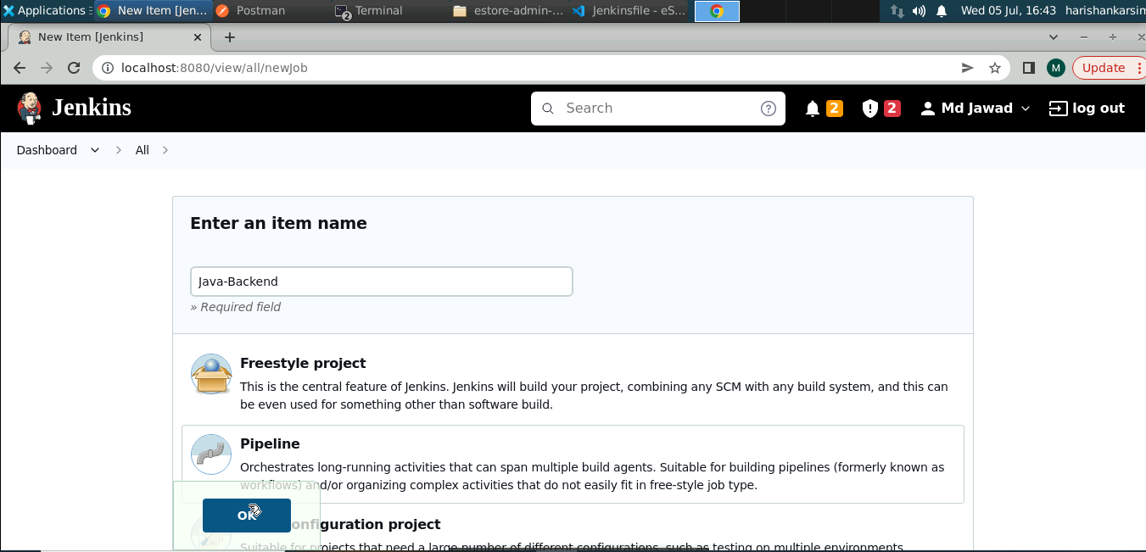

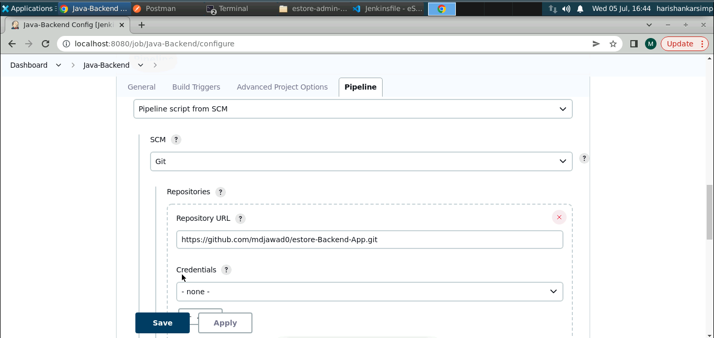

**Note:** if you get any **./mvnw permission denied** error, update the script in Jenkins file to set permission on **mvnw** scripts.

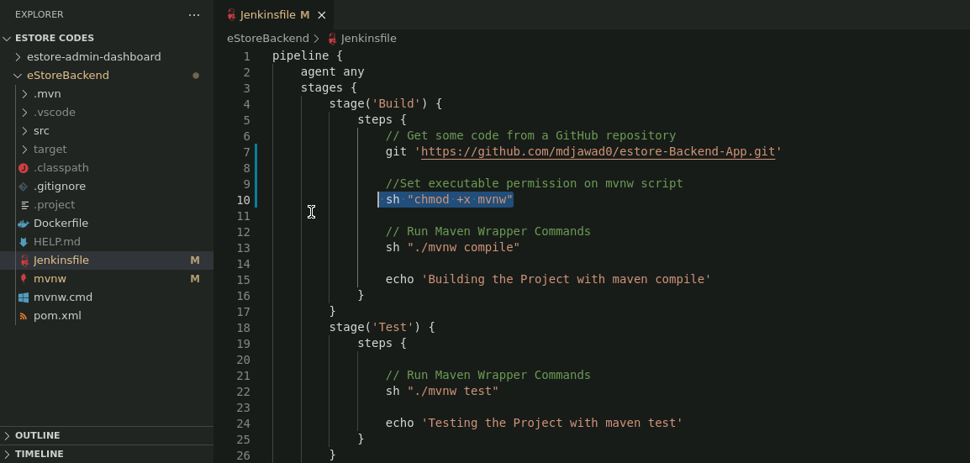

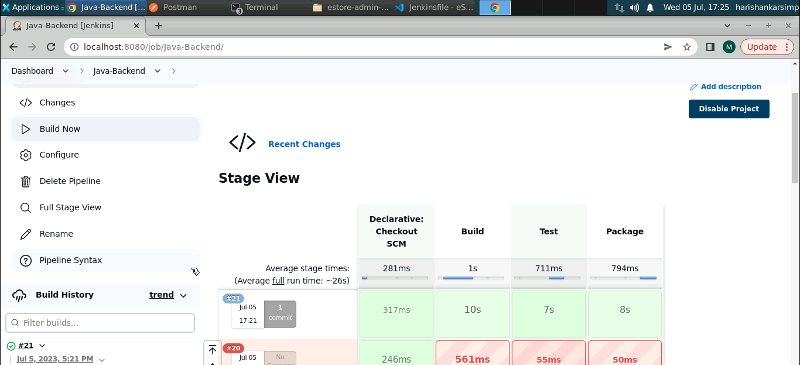

You can see all the defined stages in the Jenkinsfile are passed and successful. Please review your testcases if the pipeline fails.

**Step 7: Setting up the AWS RDS database**

1. To set up a MySQL database on AWS RDS launch the AWS lab

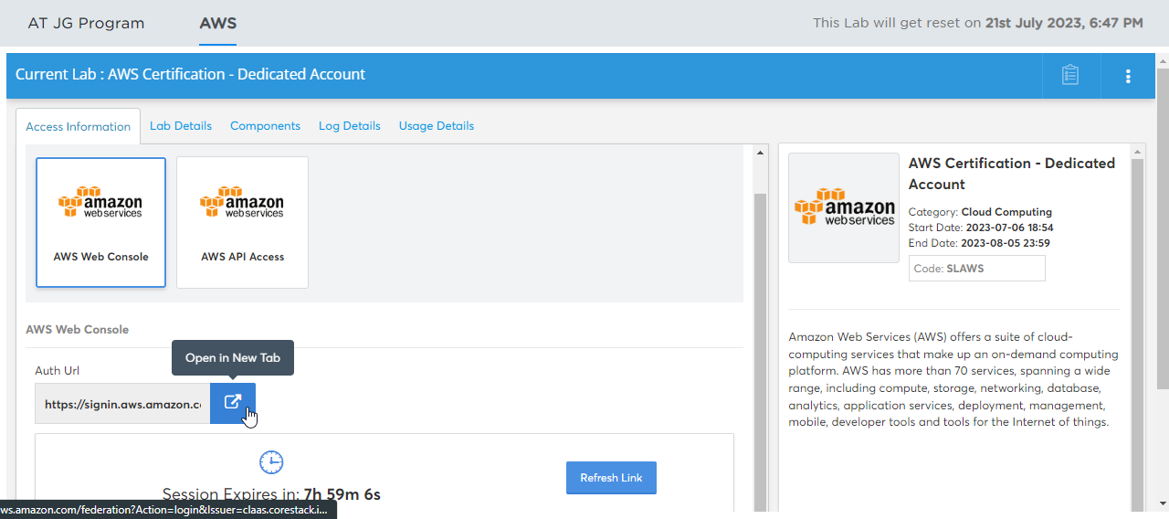

1. On the main dashboard of AWS search for RDS in the search bar

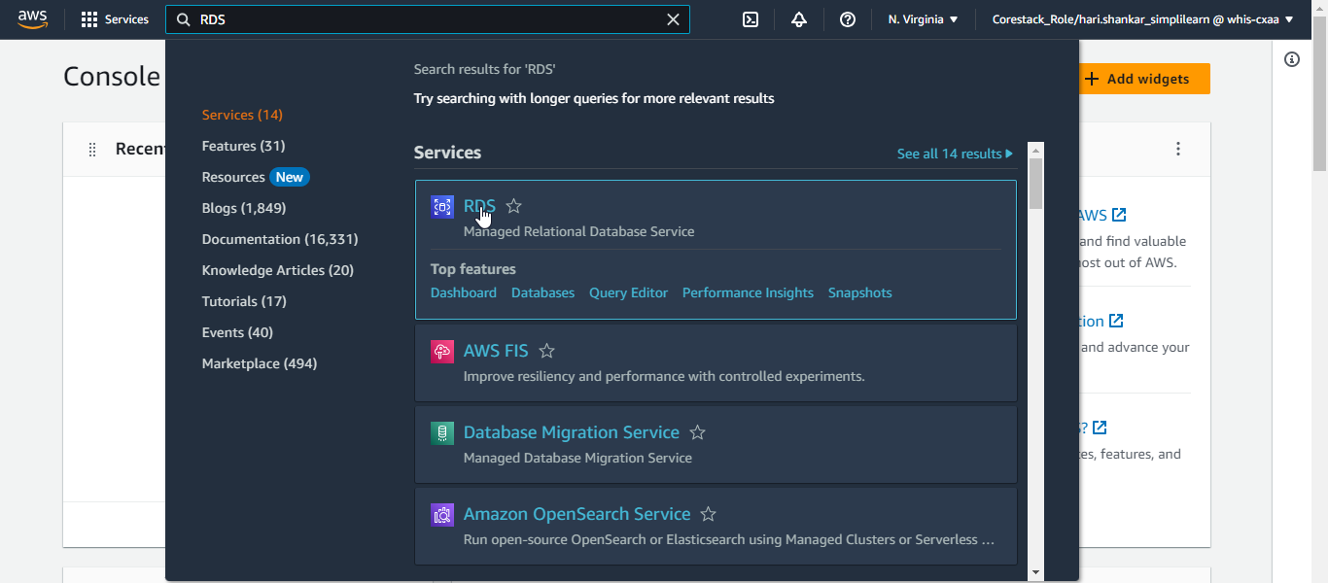

1. Click on **Create database**

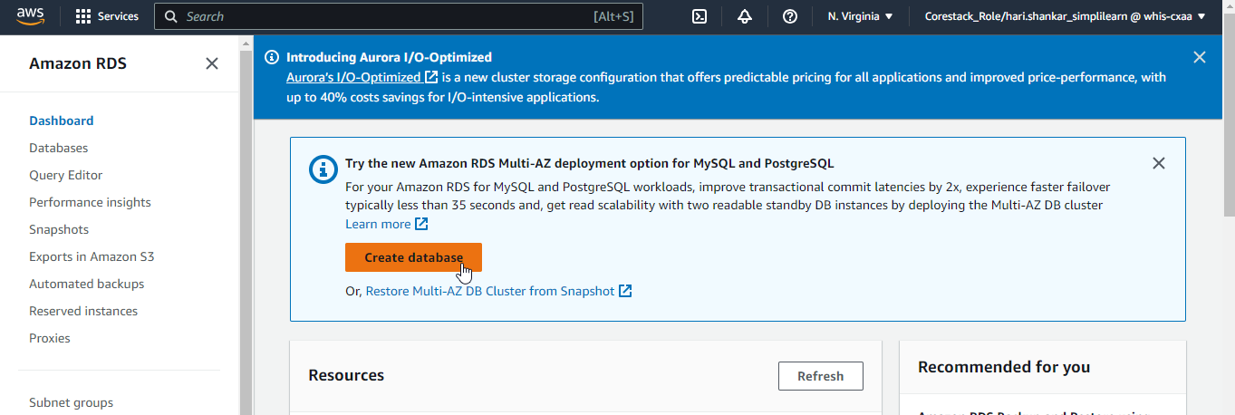

1. Choose **MySQL** as the database engine

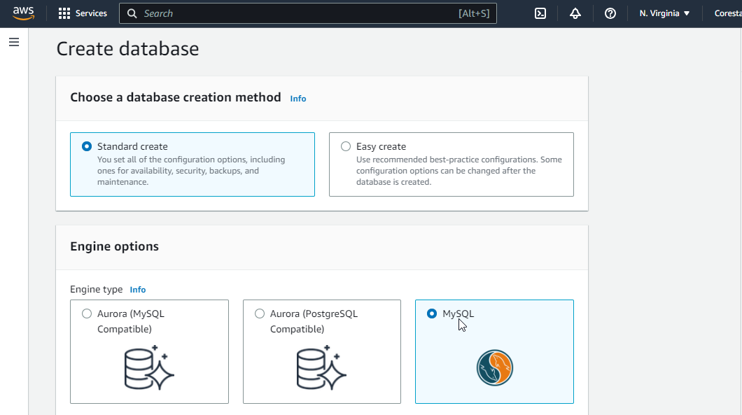

1. Choose template as free tier and provide a username and password which will be required later to connect to RDS database

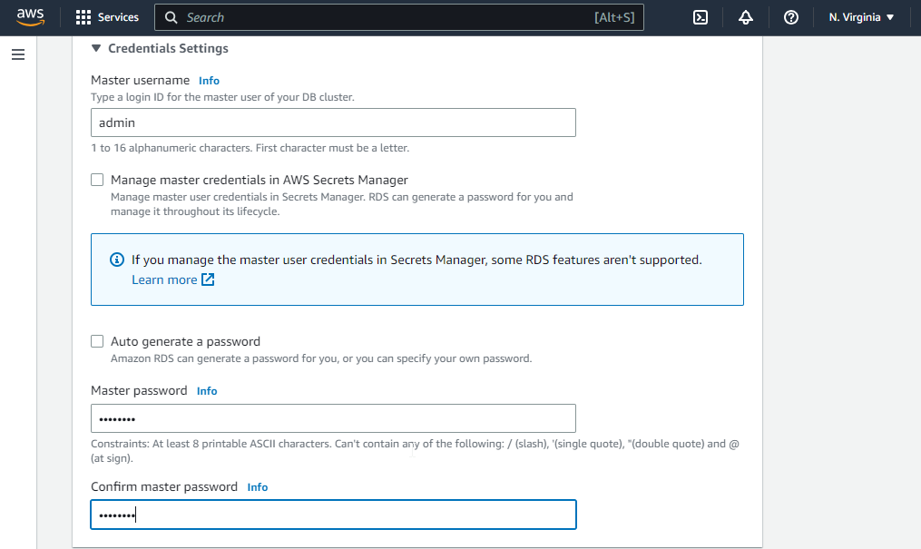

1. Set Public access to **Yes** and rest leave as default and click on **Create database**

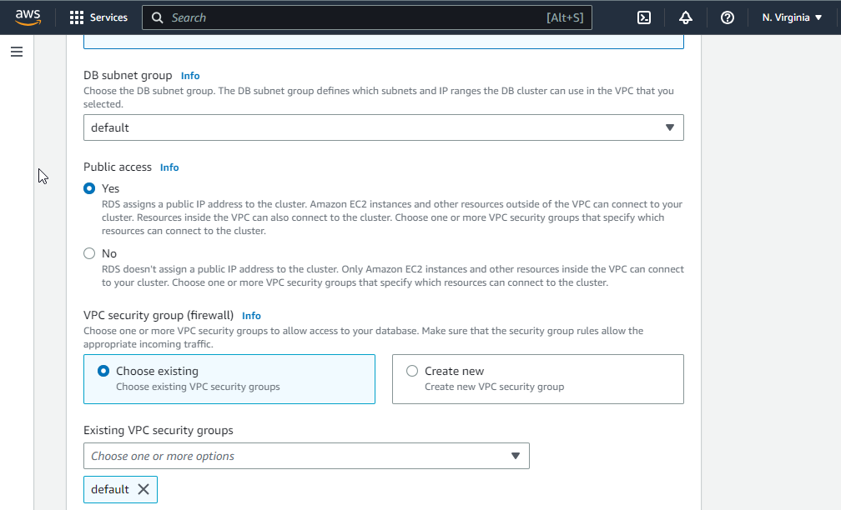

Wait for few minutes till the status of database updates to **Available**.

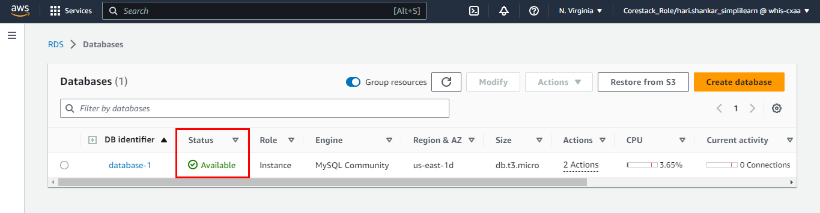

1. To access the database, add an inbound rule for port **3306** in the security group settings. Set the IP to **0.0.0.0/0** to allow access from anywhere.

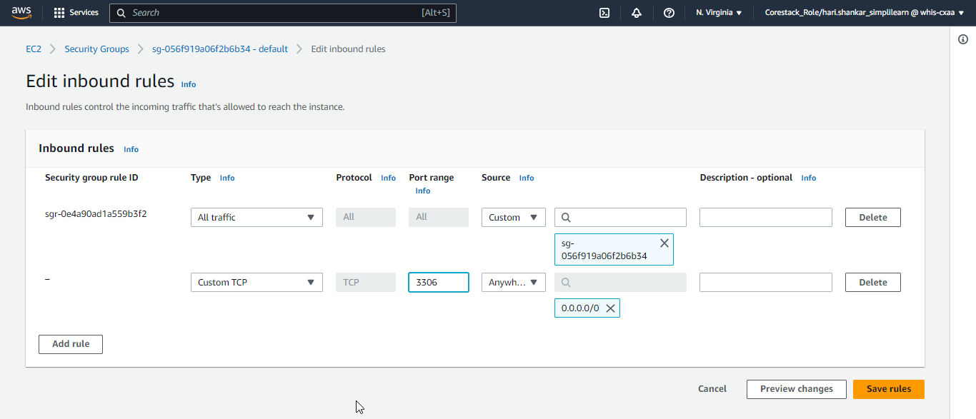

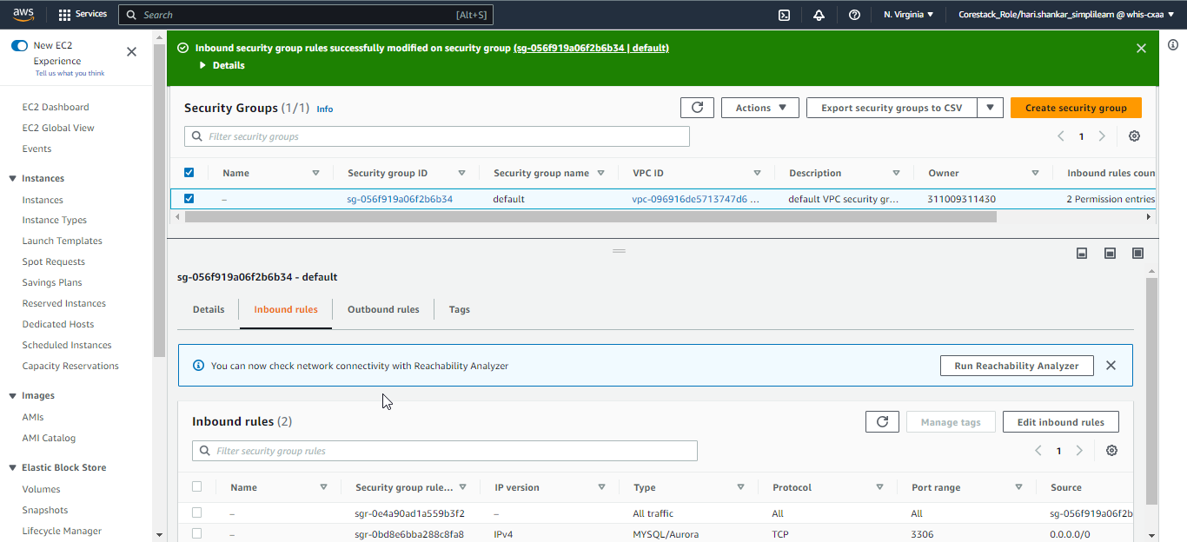

1. After the successful creation of the database, open a terminal window and execute the following command to connect to the database

**mysql -h estore.cjbfylwfrfm3.us-east-1.rds.amazonaws.com -u admin -p**

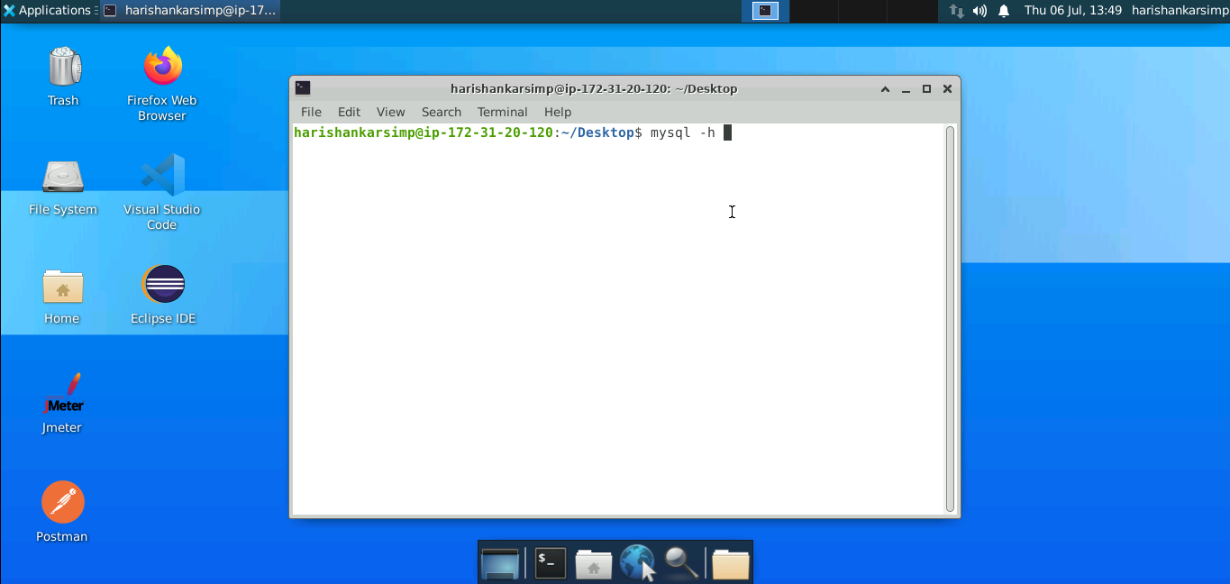

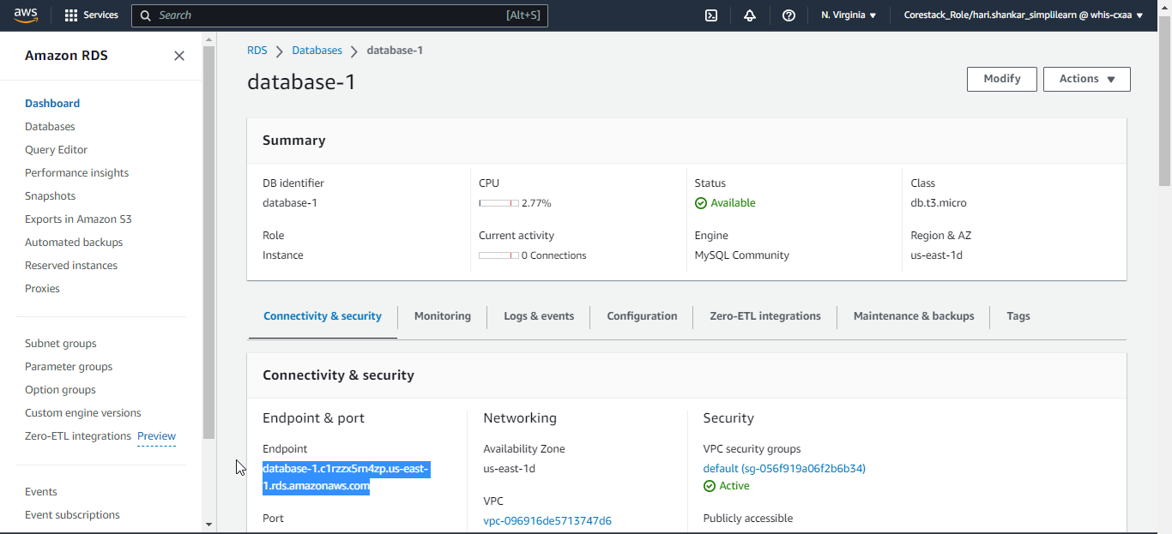

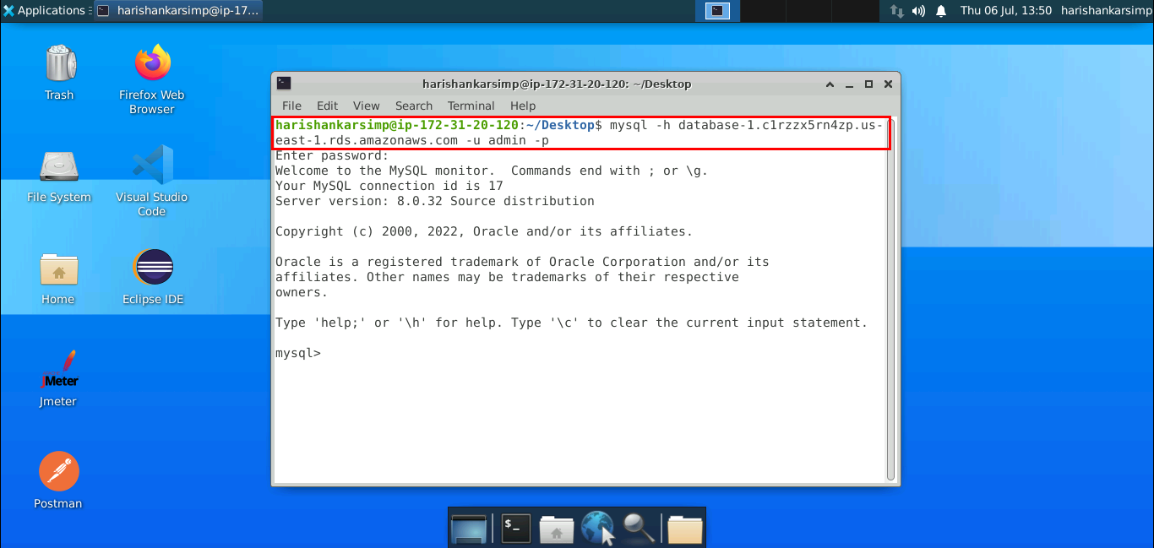

Replace **estore.cjbfylwfrfm3.us-east-1.rds.amazonaws.com**

with your database's endpoint. Enter the password when prompted.

1. Let’s create a database in the RDS which will be used for Java backend application:

**create database estoredb;**

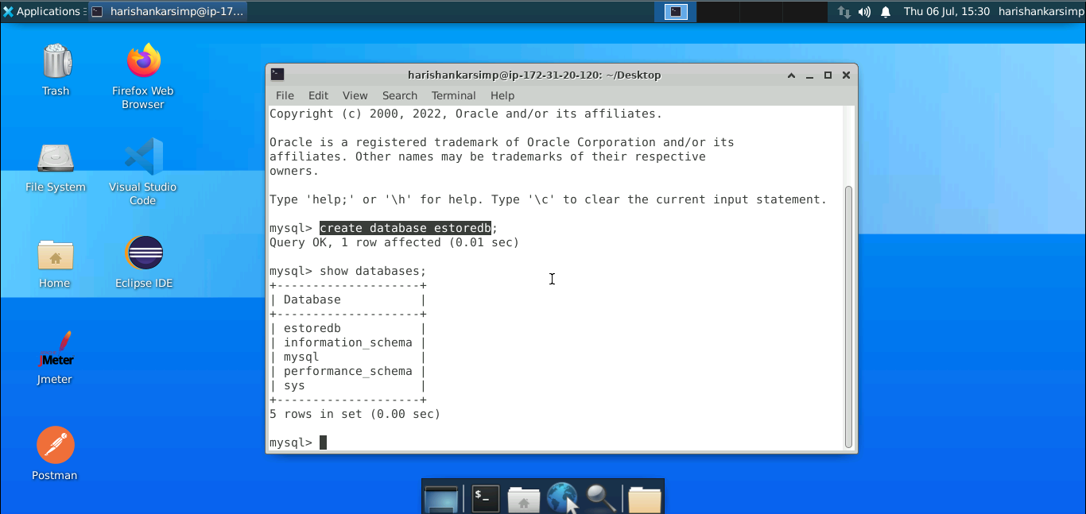

**Step 8: Setting up the EC2 instance**

1. To set up an EC2 instance, navigate to the EC2 service

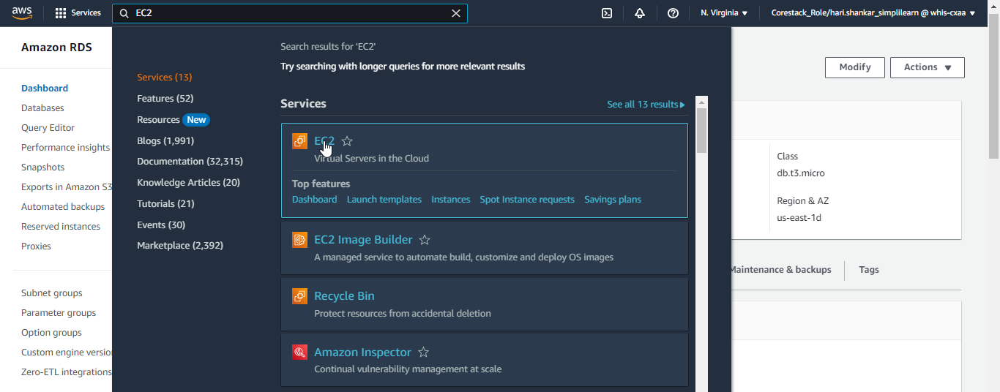

1. Click on the **Launch Instance** button in the EC2 Dashboard

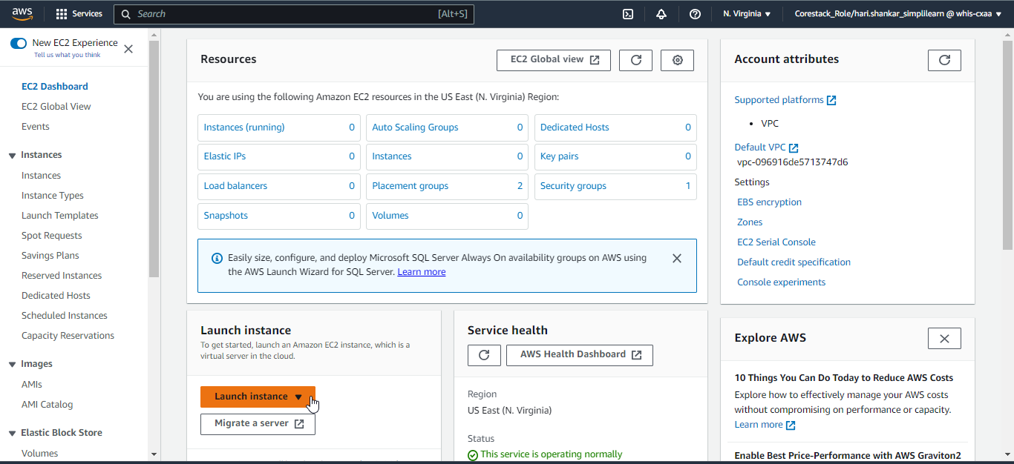

1. Create a key pair and proceed to configure the instance by selecting an **Amazon Linux** **2** image and default configuration

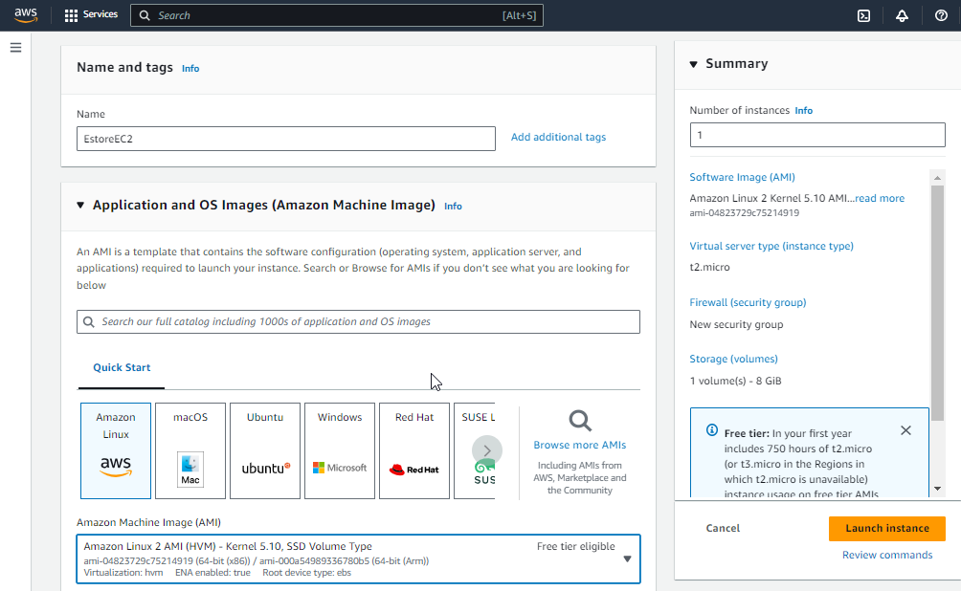

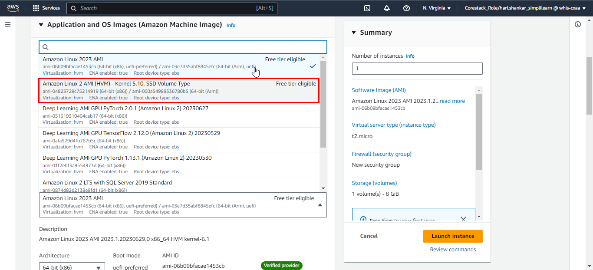

**Note**: Please choose **Amazon Linux 2 AMI (HVM) – Kernel** image and size **t2.medium**

Wait for EC2 status to be **Running**.

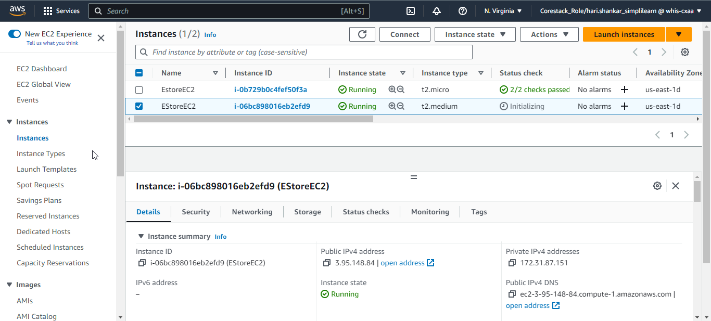

1. Once the instance is created, select the **EC2 Instance** and click **Connect**

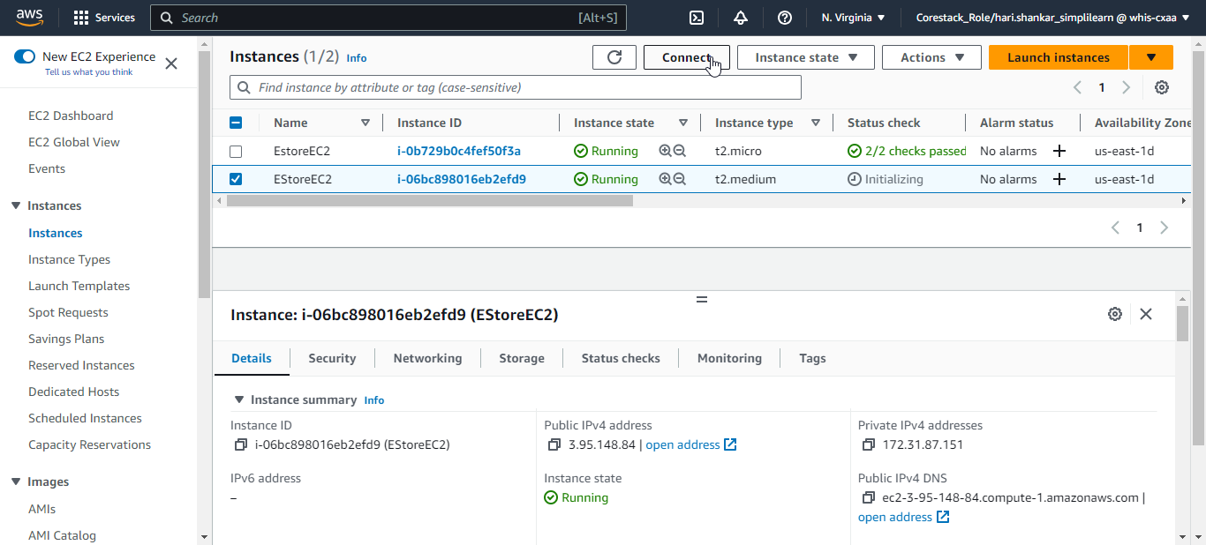

1. Now, under the **EC2 Instance Connect** tab, click the button **Connect** to establish a connection

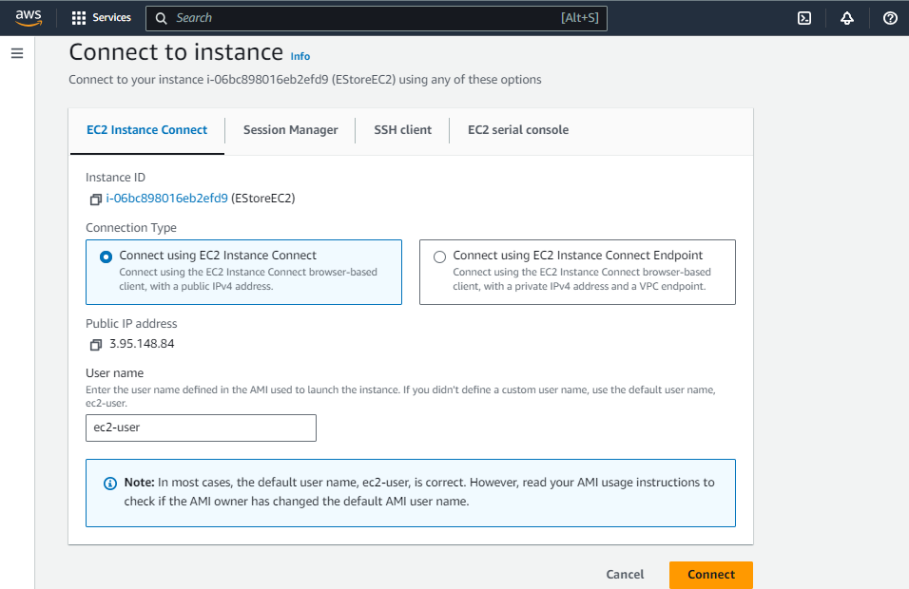

1. In the EC2 Terminal Window, run the following commands one by one to install Java 8:

**sudo yum update -y**

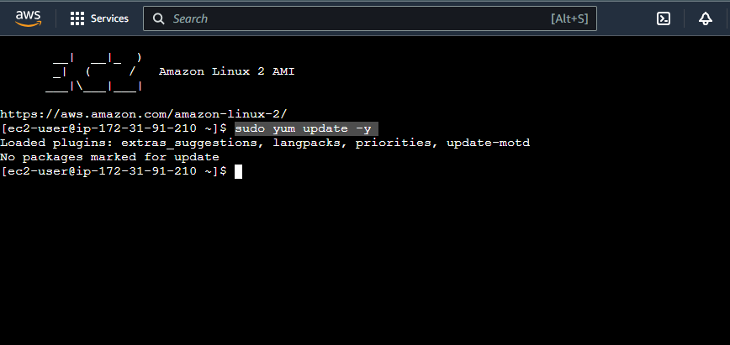

**sudo yum install java-1.8.0-openjdk**

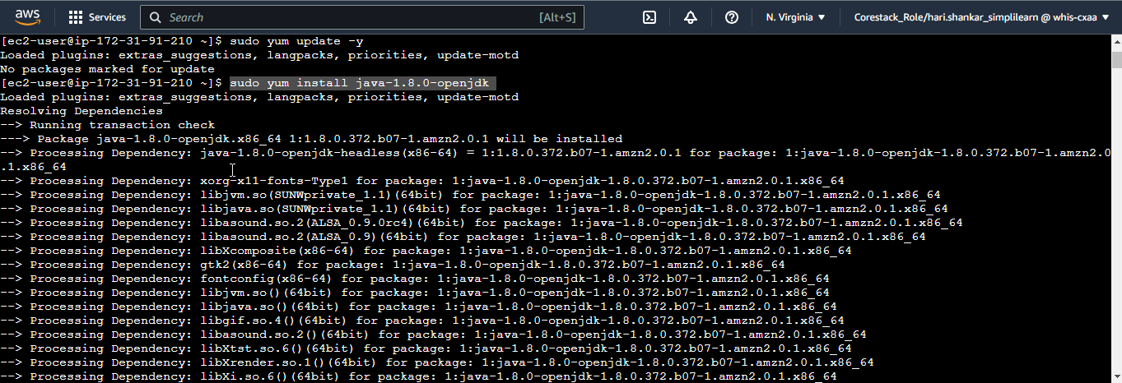

1. If you need Java 11, run the following commands to install it:

**sudo amazon-linux-extras install java-openjdk11**

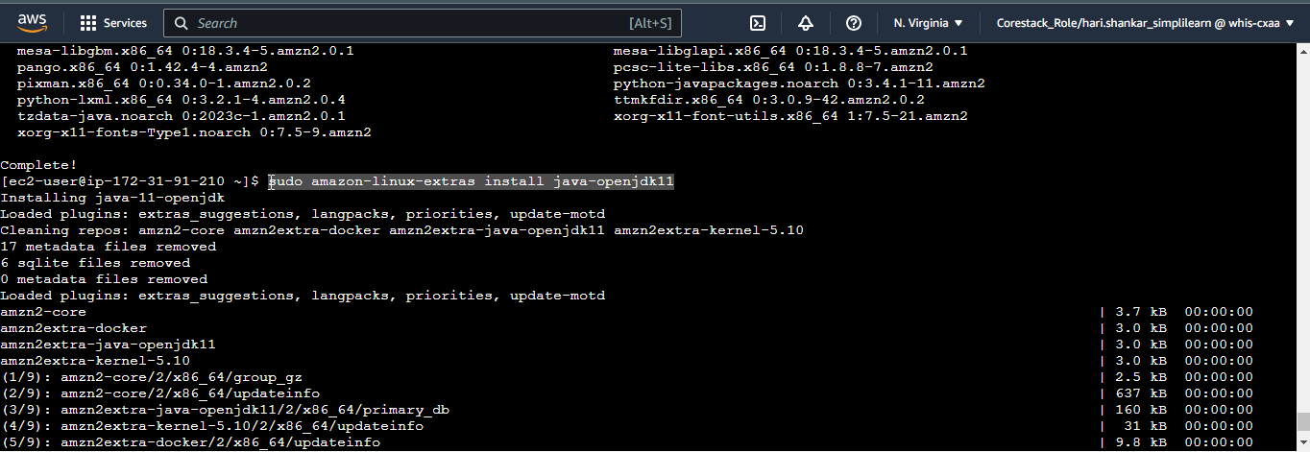

**sudo yum install java-11-openjdk-devel**

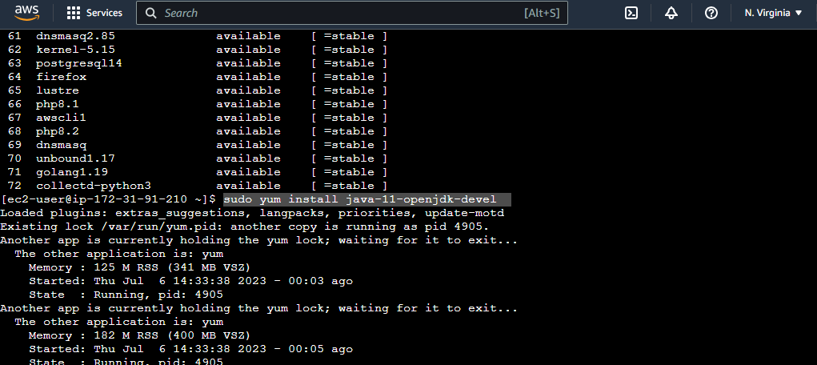

1. Use the command **sudo alternatives --config** **java** to configure the preferred Java version (**11**)

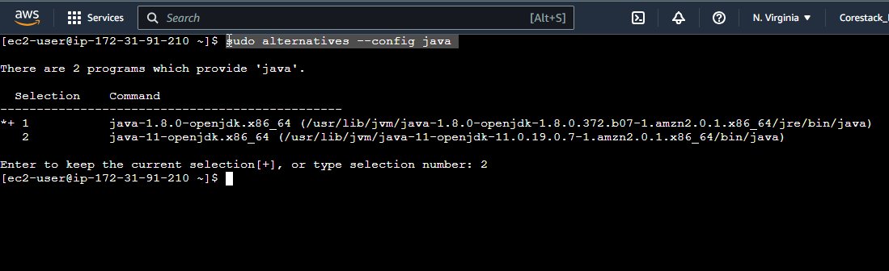

1. To configure **Node.js** on the EC2 instance, refer to the AWS documentation for the necessary commands:

**https://docs.aws.amazon.com/sdk-for-javascript/v2/developer-guide/setting-up-node-on-ec2-instance.html**

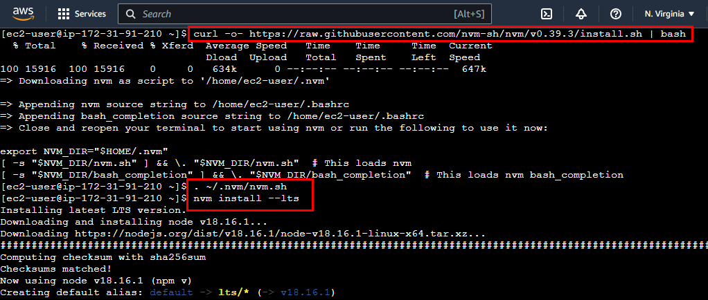

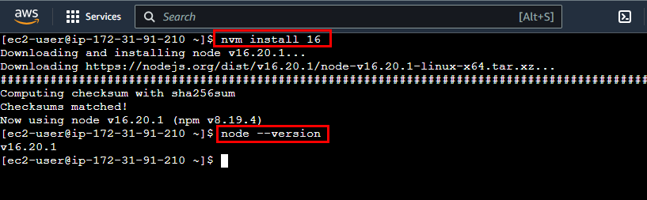

1. To install Angular CLI on the EC2 instance, use the command:

**npm install -g @angular/cli**

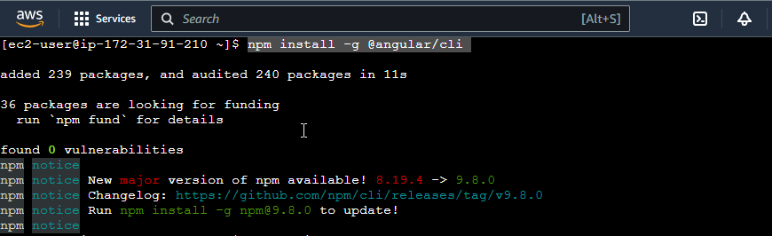

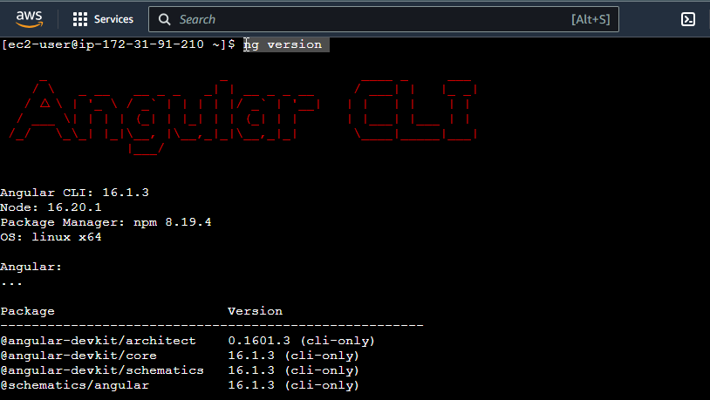

1. To install Git on the EC2 instance, run the following commands:

**sudo yum update -y**

**sudo yum install git -y**

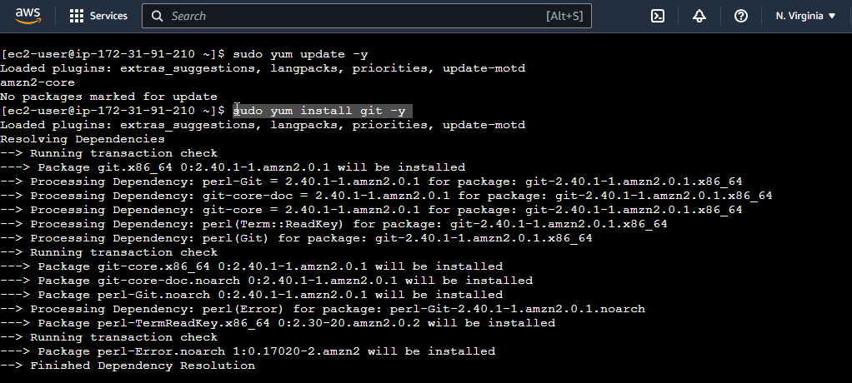

1. Check the installed Git version using the command:

**git version**

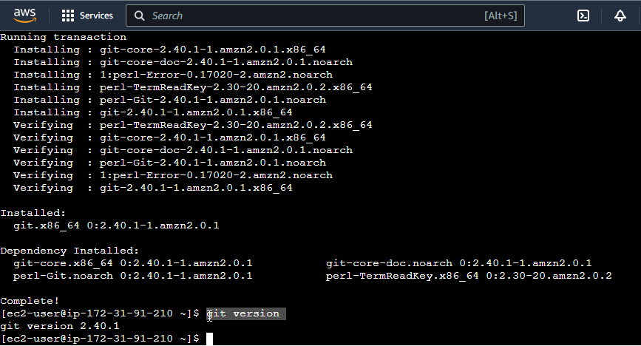

**Step 9: Deploying the applications on EC2**

1. To deploy the Java backend on AWS, configure the **application.properties** file in the Java backend project. Update the database URL, username, and password to match your MySQL endpoint.

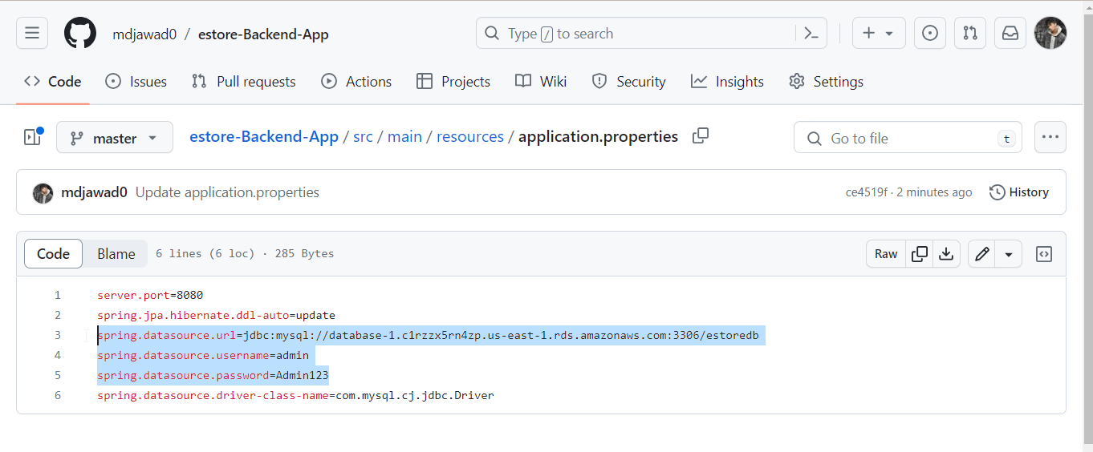

1. Comment out the code in **EStoreBackendApplication.java**

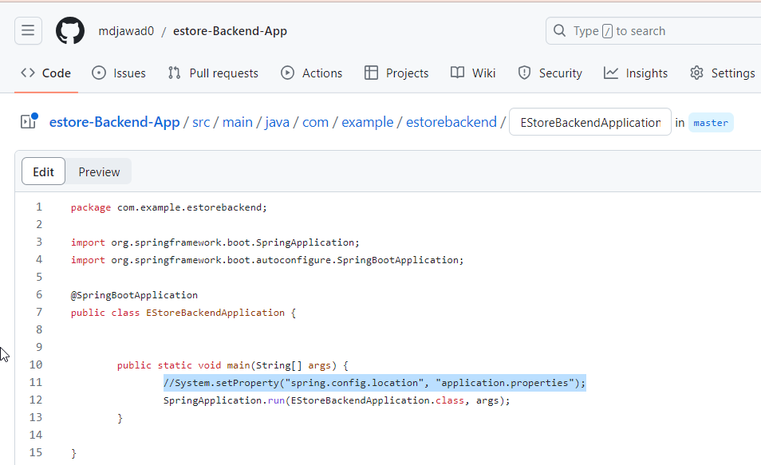

1. Update the cross origin endpoint in controller classes with EC2 endpoint URL along with **4200** port which is for Angular frontend.

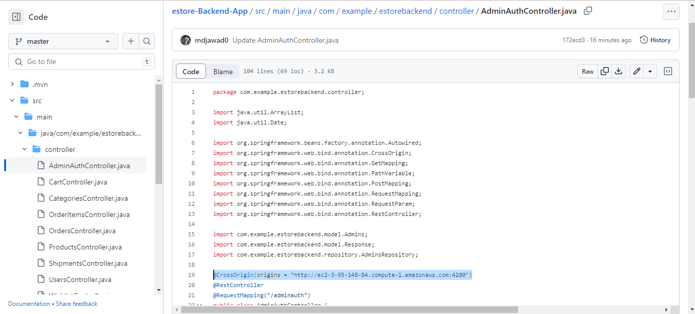

Push the latest changes to your Git repository.

1. Connect to the EC2 instance using EC2 Instance Connect and navigate to the desired directory

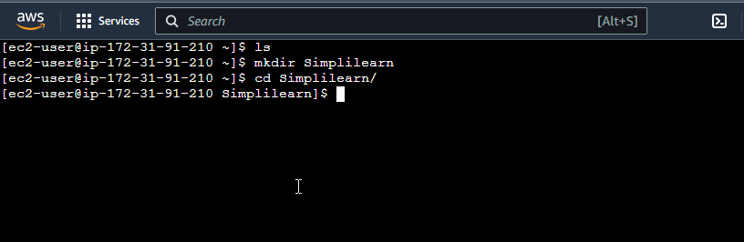

1. Clone the Java backend project using **git clone** with your repository link

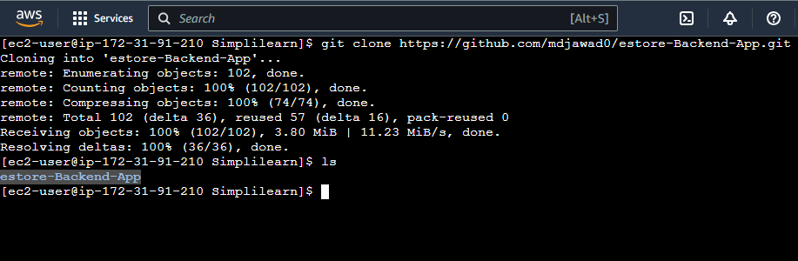

1. Change to the project directory (e.g., **cd estore-Backend-App/**) and execute **sudo** **./mvnw clean install** to build the project.

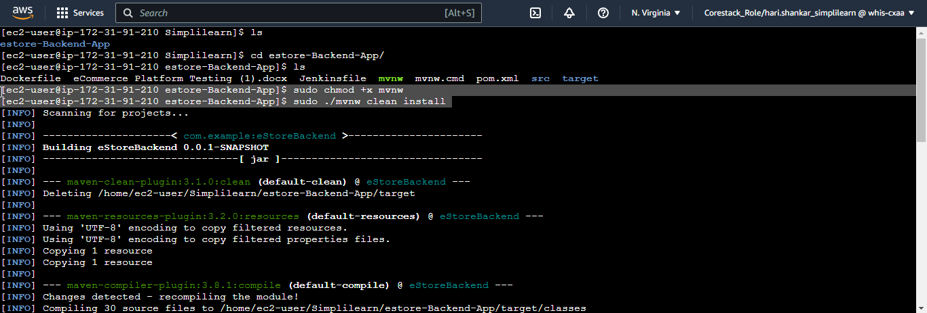

**Note:** If you get permission error, please run command **sudo chmod +x mvnw** and try again.

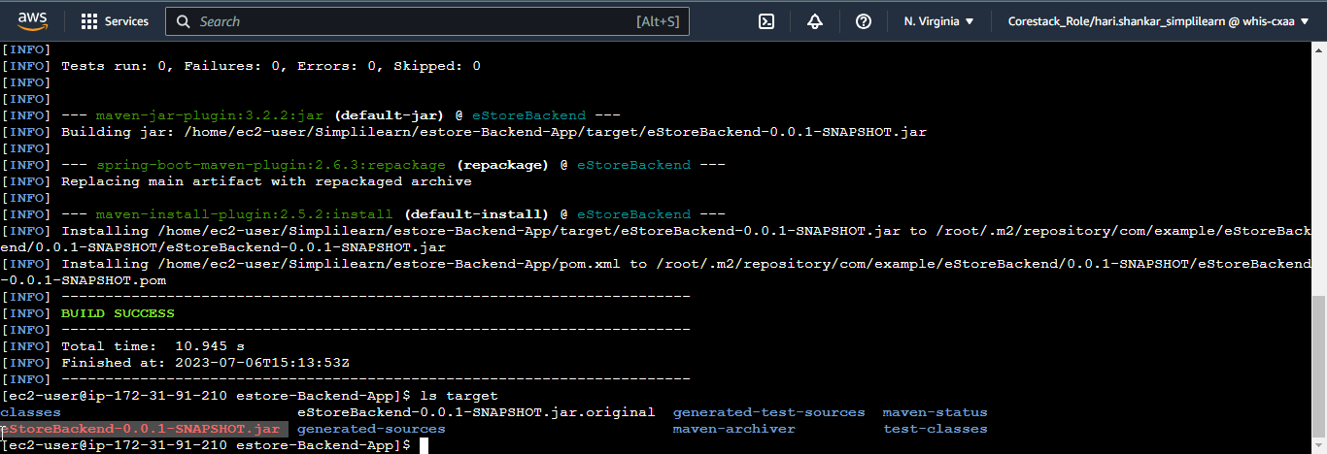

This will generate a target directory with the JAR file.

1. Ensure that port **8080** is open in the EC2 instance's security group for inbound rules

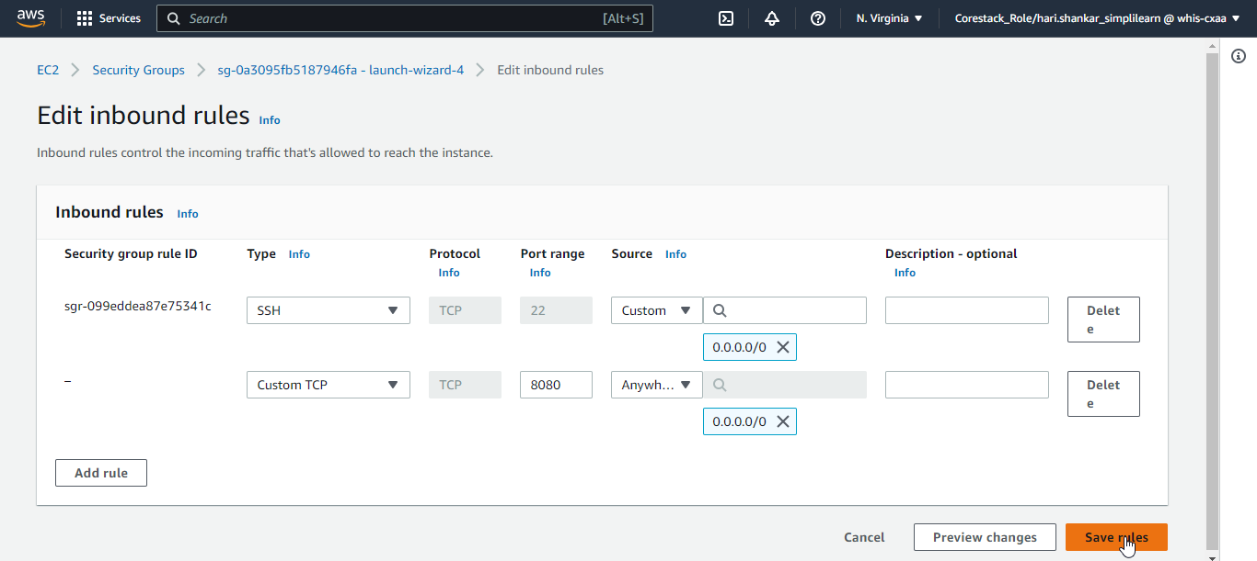

1. To deploy the Java backend, navigate to the **target** directory and execute the command:

**java -jar eStoreBackend-0.0.1-SNAPSHOT.jar**

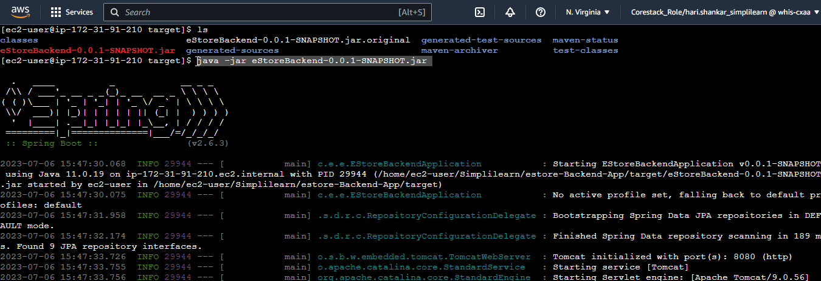

1. Access the backend using the public endpoint of your EC2 instance with port **8080**

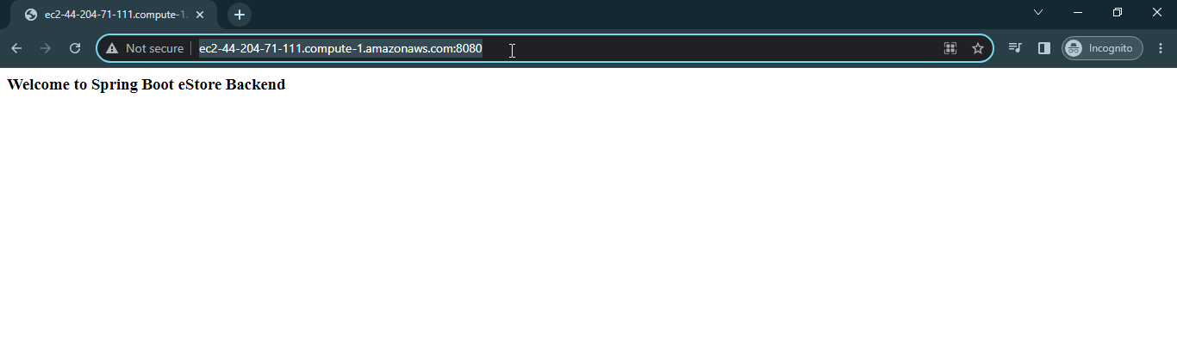

You can see the welcome message and we have successfully deployed Java backend on AWS EC2 instance.

1. To deploy the Angular admin application on AWS, update the **BASE_HREF** in the **base-urls.ts** file of the Angular admin project to the Java backend URL.

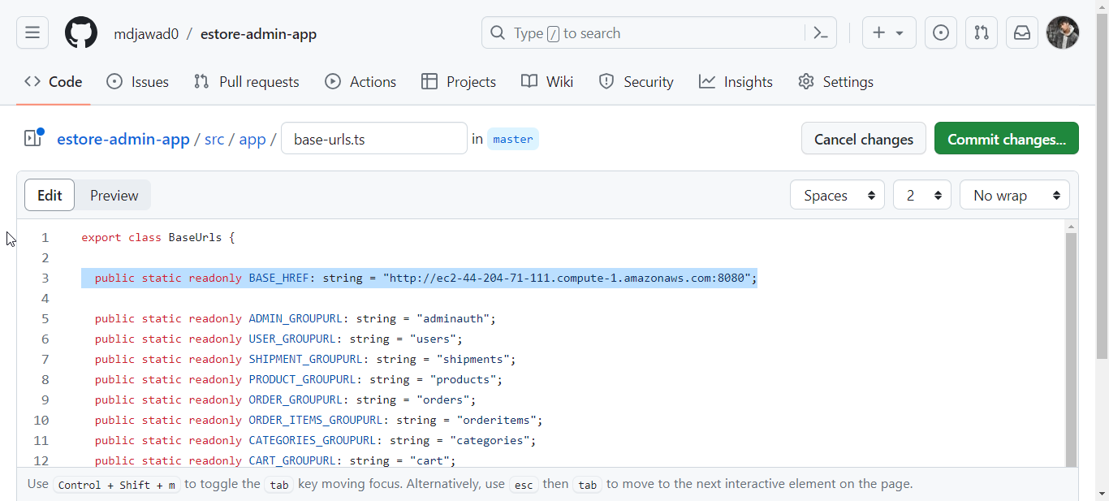

Sync the code to your GitHub repository.

1. Connect to the EC2 instance using EC2 Instance Connect and navigate to the desired director. Since the Java backend is running on the terminal lets stop it and run it again background using command:

**sudo nohup java -jar eStoreBackend-0.0.1-SNAPSHOT.jar > ~/output.log 2>&1 &**

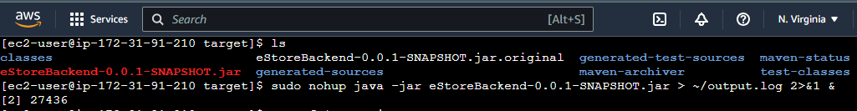

1. To verify if application is running execute the command:

**sudo lsof -i:8080**

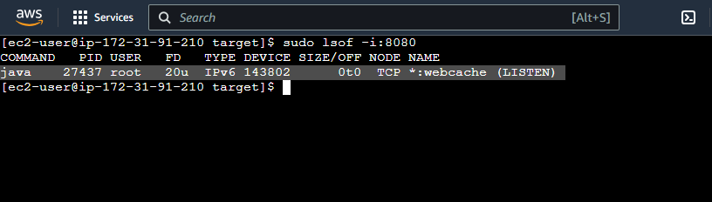

You can see PID of java backend application on **8080** same can verified from the browser with public IP address of EC2.

1. Clone the Angular admin project using git clone with your repository link

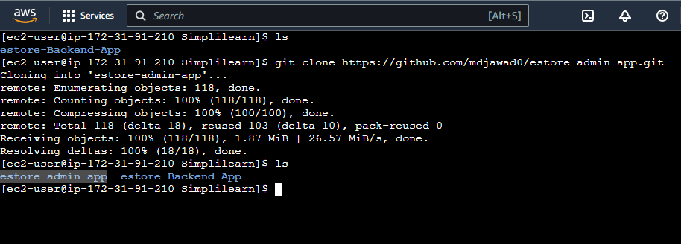

1. Change to the project directory (e.g., **cd estore-admin-app/)** and execute **npm install** to install dependencies. Use **npm audit fix --force** if needed.

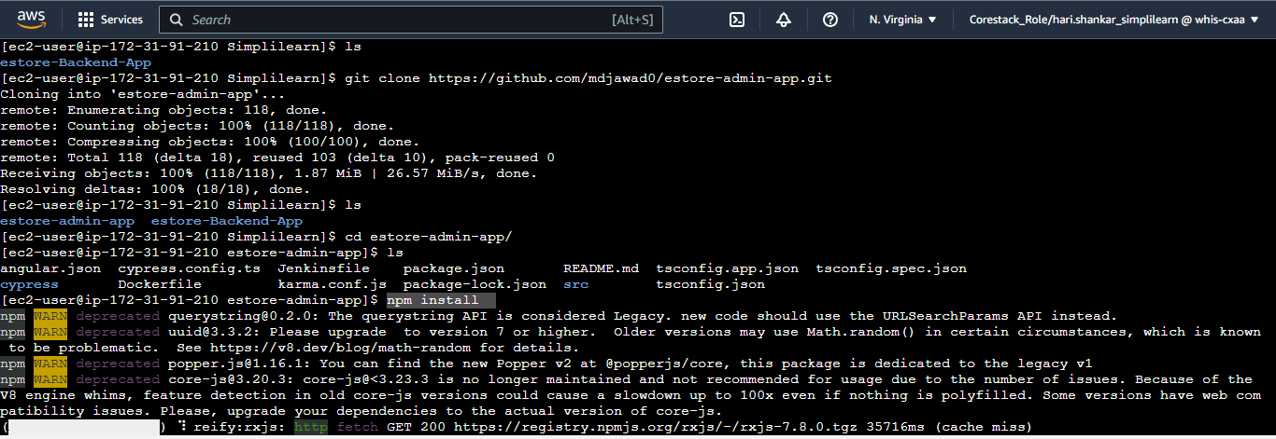

1. Install **httpd** on the EC2 instance using:

**sudo yum install httpd -y**

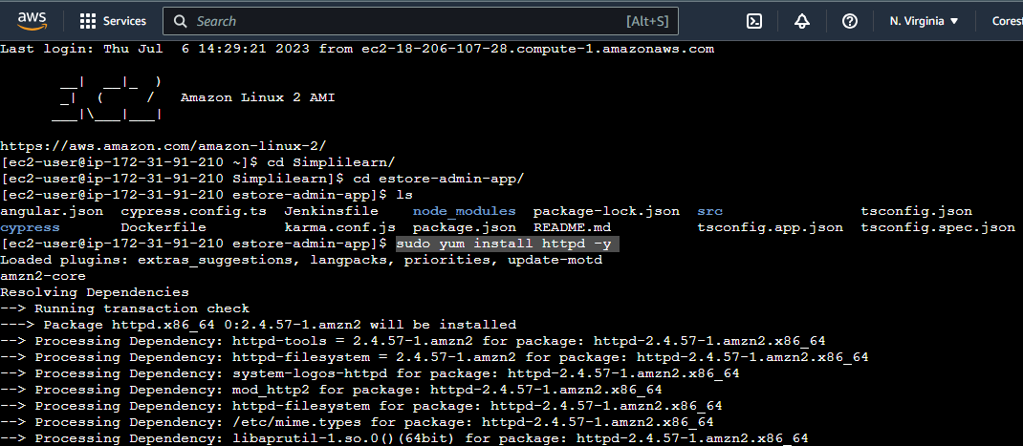

1. Edit the **httpd.conf** file with **sudo vi /etc/httpd/conf/httpd.conf** and change the port from **80** to a different port (e.g., **4200**). Save and exit.

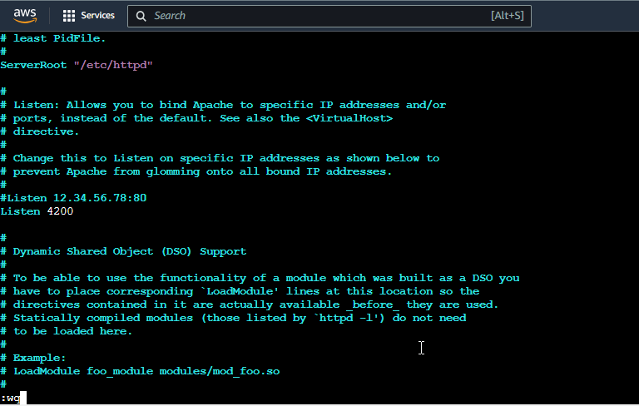

1. Restart the httpd service with **sudo systemctl start httpd.service**

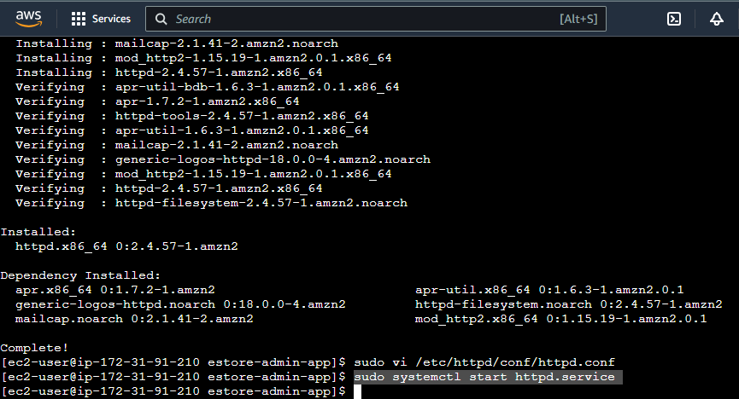

1. Execute **npm run build** in the project directory to generate the **dist** directory

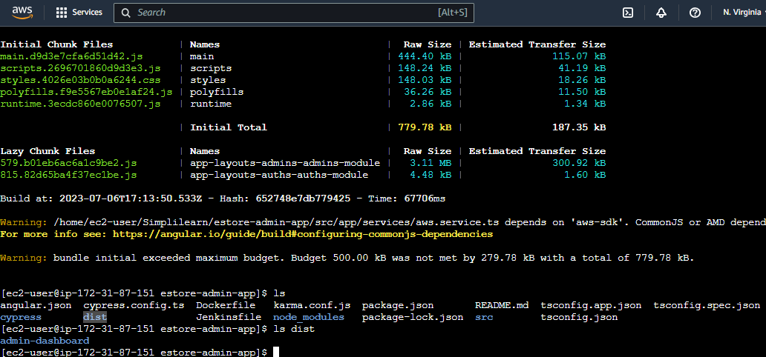

1. Copy the generated files from the **dist** directory to the **/var/www/html** directory of httpd using the command:

**sudo cp /home/ec2-user/Simplilearn/estore-admin-app/dist/admin-dashboard/* /var/www/html**

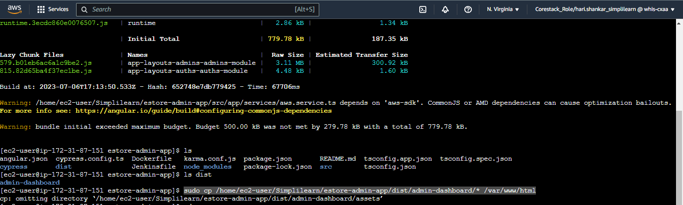

1. Ensure that port **4200** is open in the EC2 instance's security group for inbound rules

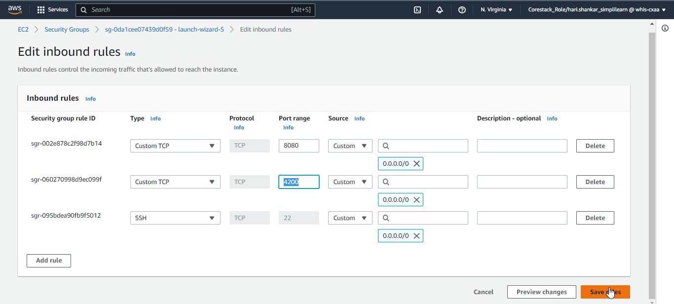

1. Access the Angular admin application using the public endpoint of your EC2 instance with port **4200**

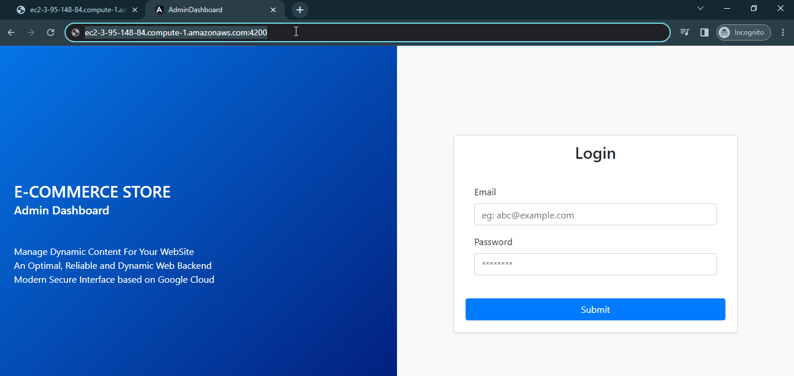

Both Angular frontend and Java backend applications are successfully deployed on Amazon EC2 instance. Let’s test if we are able to login and interact with RDS database.

1. Before login we need to add an entry record in the admins table in RDS. Insert a record to the admins table:

**INSERT INTO `admins` VALUES (1,'2023-02-10 00:00:00.000000','admin@ec2.com','Fionna Flynn',1,'admin123');**

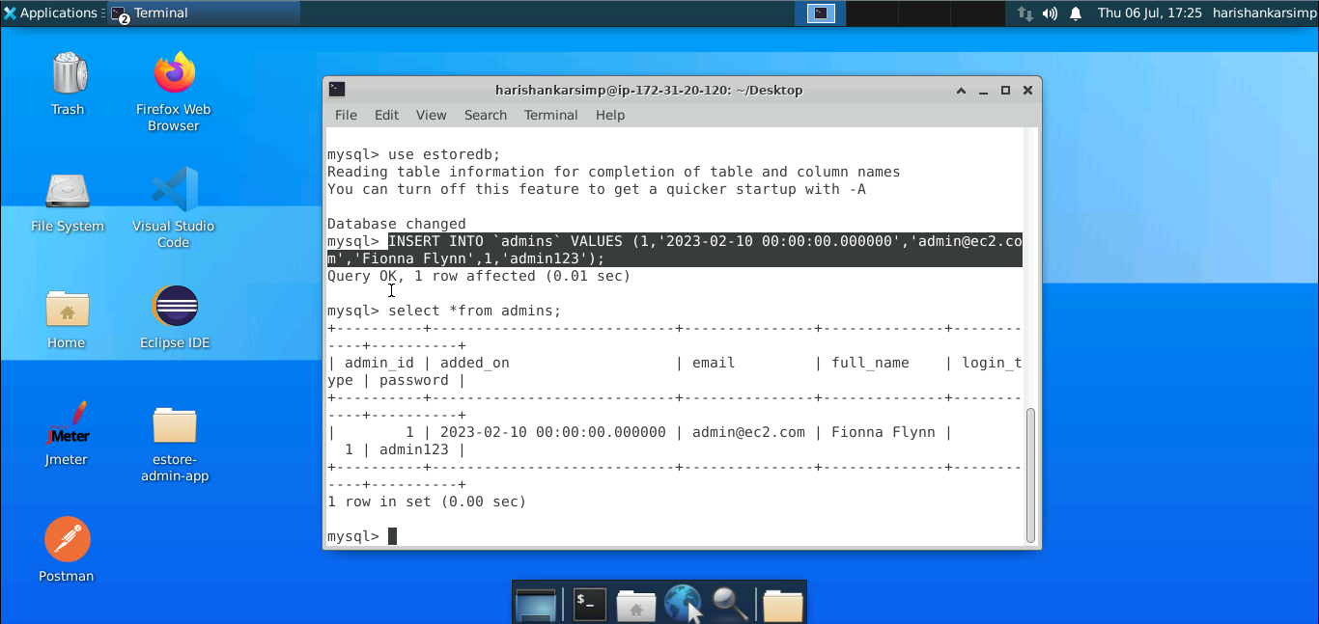

1. Login now with same added credentials

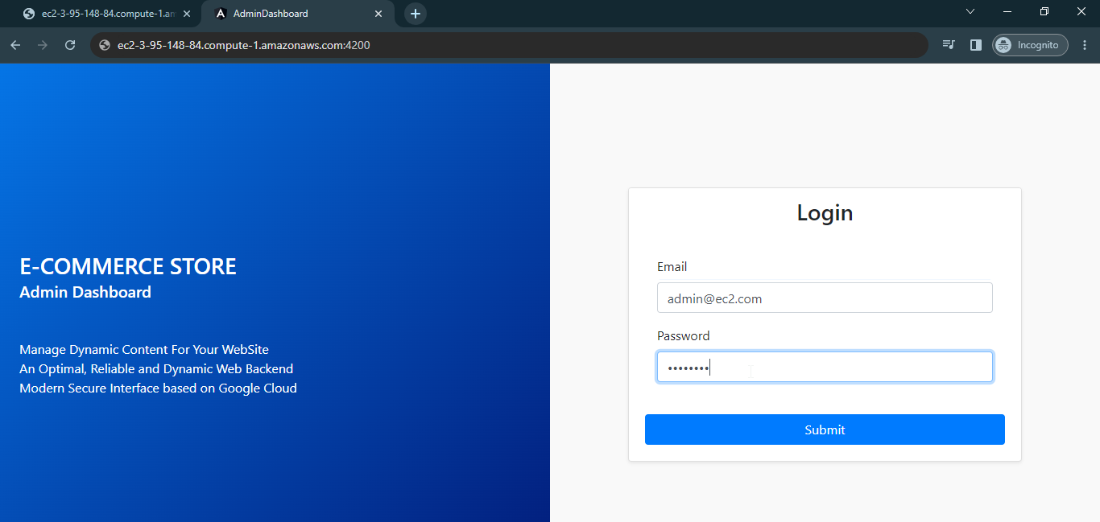

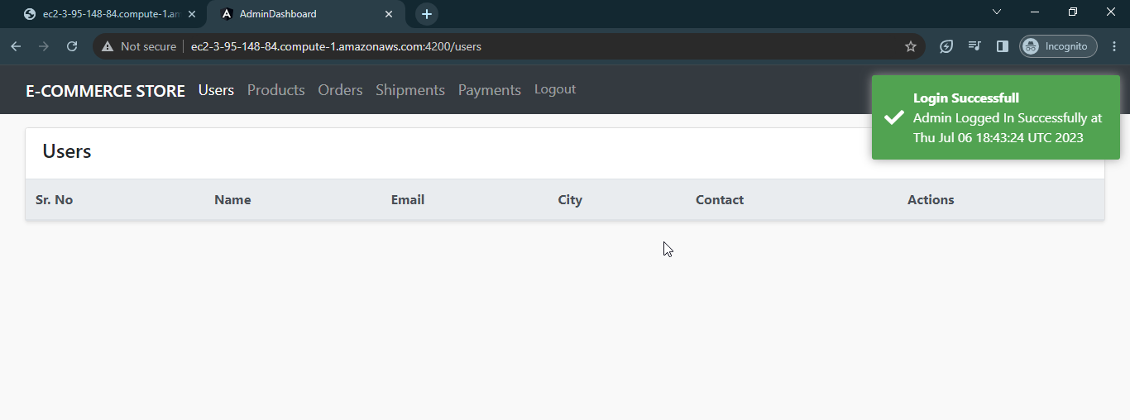

**That’s it you can successfully completed deployed the project on cloud.**